It is as if you were doing work (2017)

The evolution of…

Pippin Barr & Devolution

Abstract

@ A MAZE. / Berlin 2025

# readme.md

This is the process documentation for the game *It is as if you were doing work* (2017) by Pippin Barr.

* Read the **Press Kit** (Chapter 1) for more details on the game and press information
* Read the **Design Journal** (Chapter 2) for high-level reflections on the design and development process
* Read the **Correspondence** (Chapter 3) for a dialogue that has essentially shaped the game
* Read the **Blog Posts** (Chapter 4) for public-facing writings while creating the game
* Look at the **To Dos** (Chapter 5) for lists of practical tasks for the project
* Read the **Commit History** (Chapter 6) for detailed, moment-to-moment insights into the development process
* Look at the **File Structure** (Chapter 7) for the evolution of the source code
* Loot at **Press** (Chapter 8) to read others writing about the game

## A note on the text

The text has been edited for print, but remains as close to the original as possible. Its main purpose is to provide the original material for exploration, the data is preserved *as is* and not updated.

In addition to the process documentation Pippin Barr has also reflected on the particular development process of *It is as if you were doing work* in a conference paper[1] and later in a book[2].

## It is as if you were…

See: Love.

# Press Kit

## Info

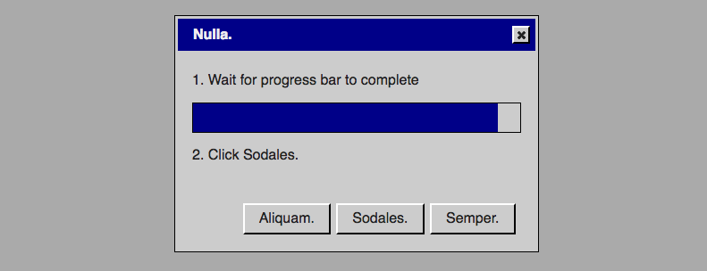

Play Online[3] (desktop only)

### Description

*The robots are here! No more work! It’s great! Is it great?! Wait! You feel apathetic and unproductive! You miss clicking buttons! You miss waiting for progress bars! You miss checkboxes! You miss work! But it’s going to be okay! Use this handy application and it is as if you were doing work!*

*It is as if you were doing work* is a work of *speculative play*[4], presenting a vision of a possible/near-future in the form of an application that helps people pretend they’re doing standard-issue computer work. Jump in an answer emails, write documents, click check boxes, and so much more!

## Press Kit

### The basics

* Developer: [Pippin Barr](http://www.pippinbarr.com/)
* Release: 5th of July, 2017, 11:00 EST
* Platform: Browser (probably mobile-unfriendly)
* Code repository: https://www.github.com/pippinbarr/itisasifyouweredoingwork/
* Price: $0.00

### Who is this Pippin Barr guy?

Pippin is an Assistant Professor in the [Department of Design and Computation Arts](http://www.concordia.ca/finearts/design.html) at [Concordia University](http://www.concordia.ca/) in Montréal.

He works within the [Technoculture, Art, and Games (TAG) Lab](http://tag.hexagram.ca/) which is part of the [Milieux Institute for Arts, Culture, and Technology](http://milieux.concordia.ca/). In fact right now he’s the associate director of TAG!

### History

*It is as if you were doing work* had been around for a long time before I really managed to start working on it properly. I actually documented the original moment that sparked that game in a blog post titled [Close analysis of having a game idea](http://www.pippinbarr.com/2016/08/15/close-analysis-of-having-a-game-idea/) - basically I was watching Rilla resizing an image while working on a project and suddenly felt like it would be amazing to have a game entirely premised on totally conventional operations with traditional user-interfaces. From there it became the idea of a WarioWare-esque game where you would complete simple interface operations under time pressure (I will likely return to this) with various ideas for layering on some kind of meta-narrative, or AI-twist, or something to make it more ‘spectacular’.

After a couple of months with it on the back-burner, I came back to the game thinking mostly in terms of technologies. Specifically, I was teaching a web development course at university and started thinking it would be interesting to build a game using a kind of standard-issue user-interface library like jQuery as opposed to building it with a game engine. It felt like there was something appropriate about using tools that actually fit in with the nature of the game as interface-oriented. So at that point I started nailing down what I’d actually be able to implement with jQuery UI’s tools (e.g. checkboxes, radio buttons, buttons, progress bars, etc.).

At a certain point while working on the actual underlying framework I tried to name the game and realised it could actually serve as a kind of sequel to *It is as if you were playing chess*, hence: *It is as if you were doing work*. The title gave some more structure to what the game was meant to be about. Rather than being WarioWare-style zany fun with interface elements, it now needed to fit into the *It is as if* idea of a performative game that enables you to simulate an activity.

Making the game a sequel briefly led me down a path of trying to make an incredibly abstract version where there was little to no actual language and the texts were represented with unicode block characters instead. The UI was styled in a similar way to *It is as if you were playing chess* with clean white lines on a dark grey. It actually looked pretty good, but it became so abstract that it was less and less clear that the was about anything. When playing around with the interface elements I had a feeling of detachment, rather than the sense of simulating work.

I had a break-through on this front in New Zealand when I decided to style in interface so it looked like Windows 95 to some extent. Having a kind of clunky ‘old-timey’ UI style made the game lighter hearted and also allowed me to go back to thinking about actually legible content for the interfaces. It pretty quickly settled into more of a desktop OS model of windows and dialogs popping up, with the user performing tasks that both looked and felt like work: typing, moving sliders, clicking on icons.

With the look settled, the content started being decided by the fact I was thinking about this project as part of the [Speculative Play](http://www.speculativeplay.com/) project I’m part of with my colleagues Rilla Khaled (who also happens to be my wife) and Chris Moore. That project is about creative interactive, playful media that speaks to alternate presents or near/distant futures. I positioned *It is as if you were doing work* in the context of the apparently near future of automated work (I read [*Rise of the Robots*](https://www.amazon.ca/Rise-Robots-Technology-Threat-Jobless/dp/0465097537) by Martin Ford recently in this vein). Thus the game poses as an application that humans who have been put out of work by robots and AI can play as a way to recapture the sense they once had of doing work and being productive. It’s a kind of semi-condescending service offered by this new world to those of us who can’t deal with it.

And that’s how the game came together.

### Technology/Media

*It is as if you were doing work* is written in JavaScript using [jQuery](http://www.jquery.com/) and [jQuery UI](http://www.jqueryui.com/), two of the quintessential libraries for web development. The sound effects for *It is as if you were doing work* are pulled from Windows 95 and Windows 98 system sounds, while the music was generated using [Wolfram Tones](http://tones.wolfram.com/). The desktop icons in the game are from Windows 95, the desktop pictures are all creative-commons zero-attribution or public domain, and the inspirational images are all watermarked stock images of work. The technology names are from Darius Kazemi’s amazing *corpora on GitHub*[5]. The theming of the dialog boxes was created in jQuery UI’s [ThemeRoller](https://jqueryui.com/themeroller/).

### Features

* Text areas!
* Checkboxes!
* Radio buttons!
* Sliders!
* Date pickers!
* Progress bars!
* Buttons!
* Inspirational stock photos!
* Videogame!

### Videos

#### *It is as if you were doing work* Trailer[6]

[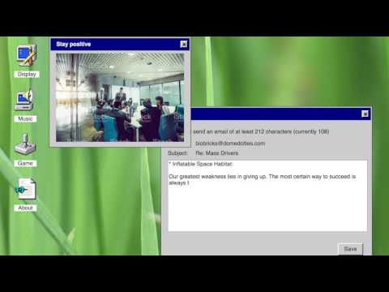](https://www.youtube.com/watch?v=RDMiRiHcezI)

### Images

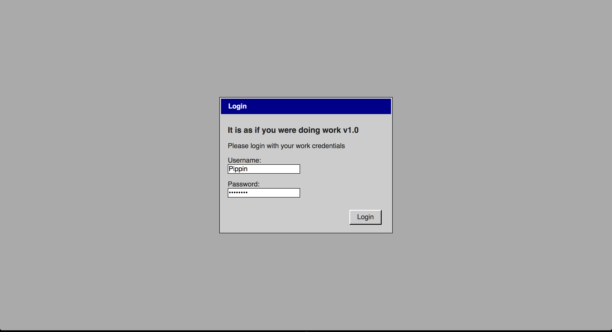 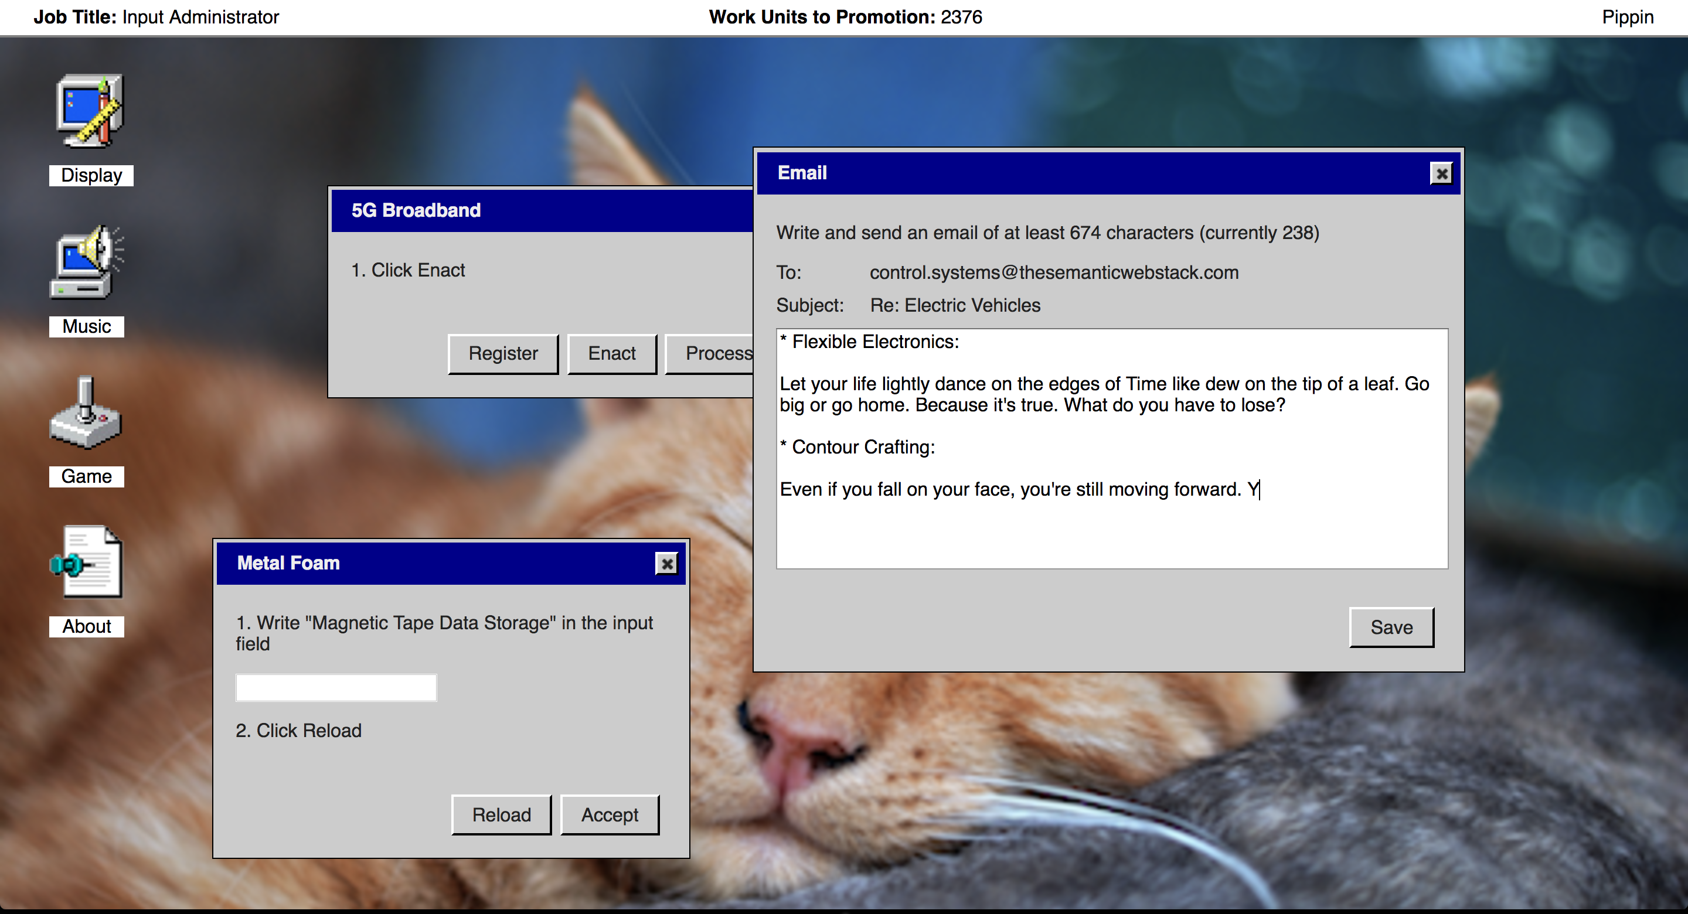 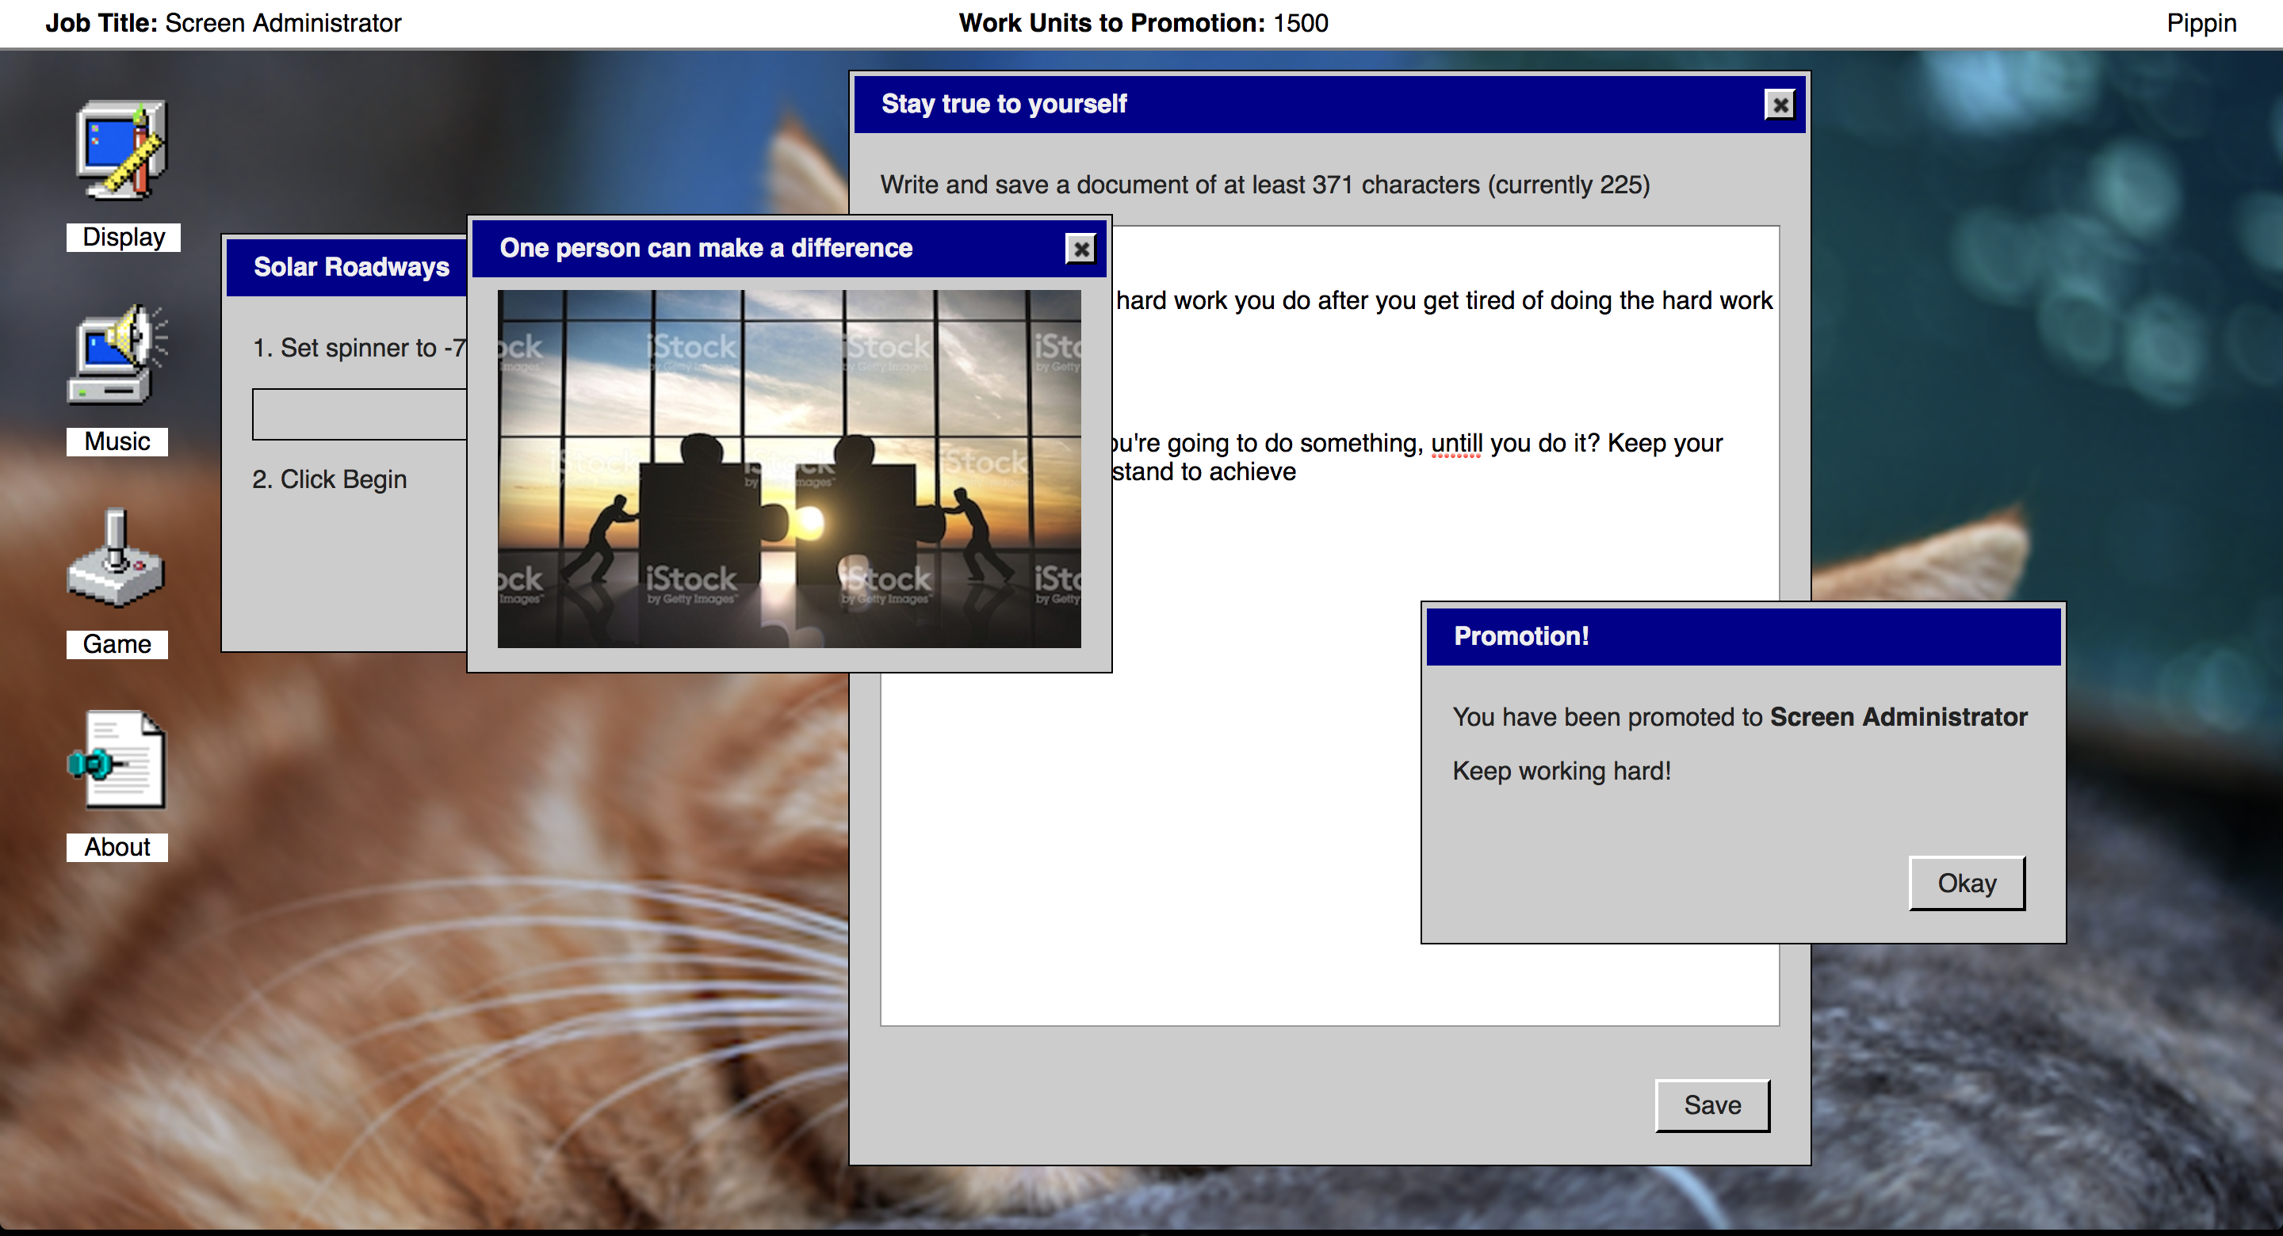 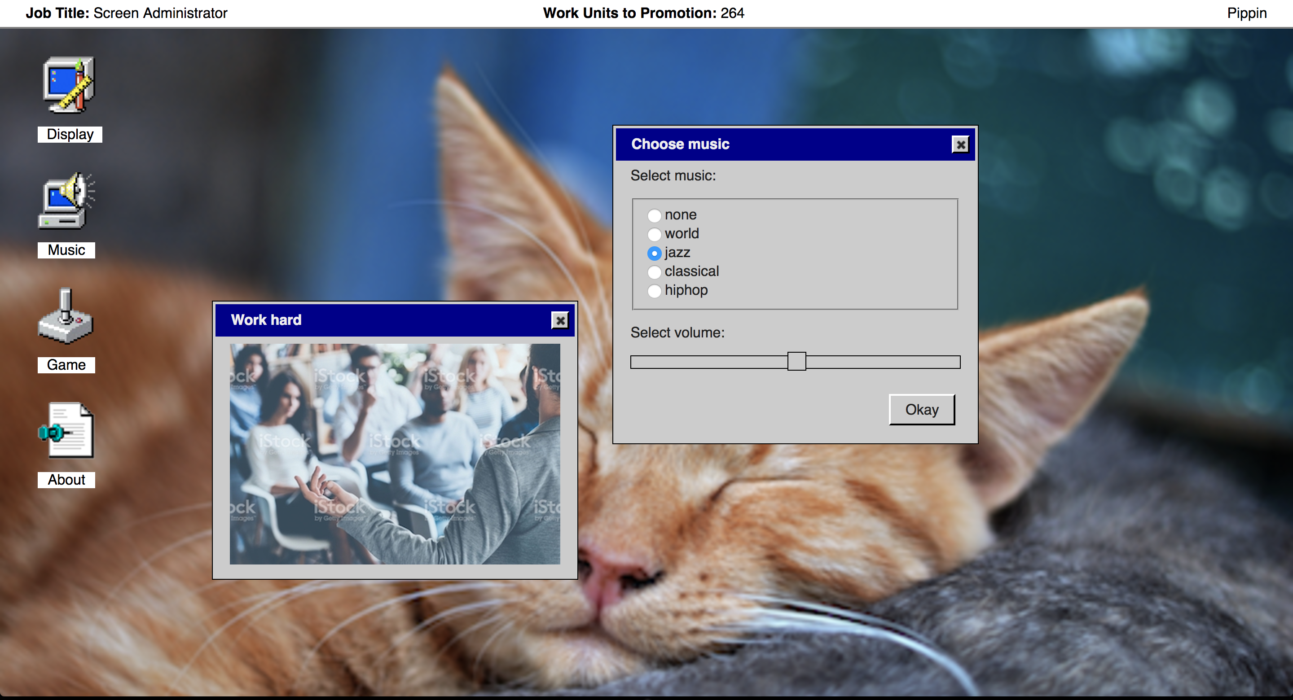 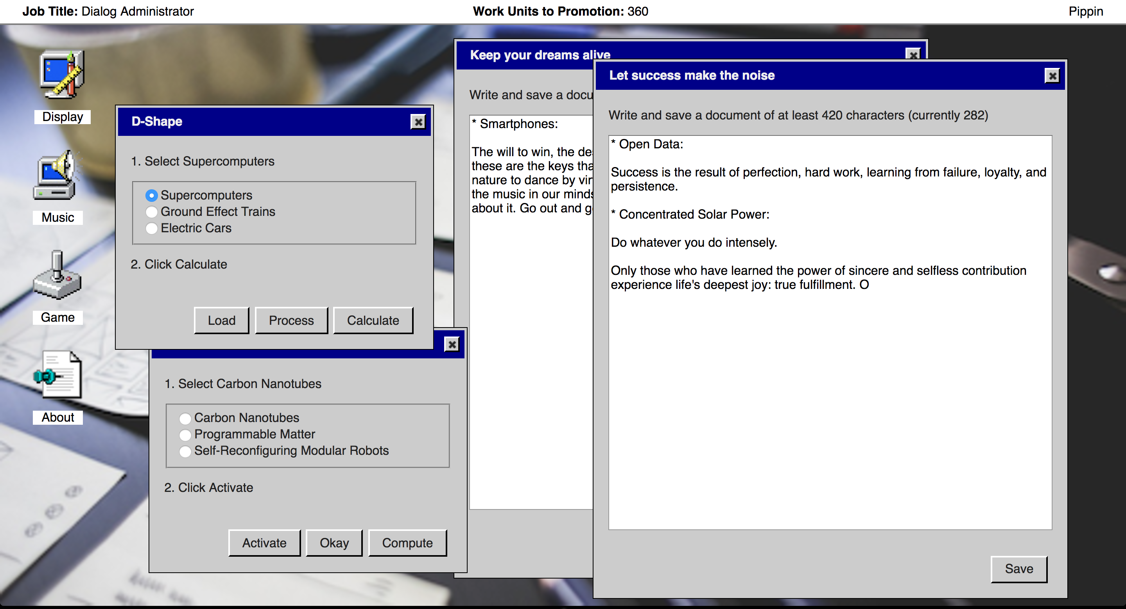 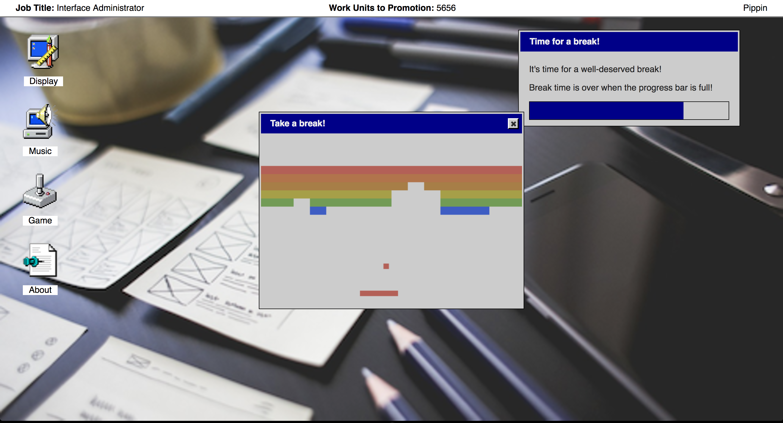

### Additional Links

* [E-tray Exercise](https://www.assessmentday.co.uk/e-tray-exercise.html) - Real world dystopian interface to train people to work with email ([assessmentday.co.uk/e-tray-exercise](https://www.assessmentday.co.uk/e-tray-exercise.html))
* [In Europe, Fake Jobs Can Have Real Benefits](https://www.nytimes.com/2015/05/31/business/international/in-europe-fake-jobs-can-have-real-benefits.html) - New York Times article about fake businesses used for training

### Credits

* Pippin Barr: everything.

# journal.md

## Tuesday, 30 August 2016

### The basic idea

A game made entirely of small (WarioWare-esque) activities from our daily life of using computers. So, for instance, you might be challenged to drag a folder into the trash, or move a slider to a specific setting.

### More depth

There’s a question of what this is actually about. One option is pure WarioWare style madness where there’s a heavy time limit and you succeed or fail rapidly. Another is that it’s more of a time trial where a clock runs up and you’re trying to be “good” at using the UI rather than pass/fail. In some ways I prefer that. It’s also something that could be put into tension if I pursued a more narrative concept of the game.

A narrative twist? One twist would be to incorporate narrative into the texts and imagery in the game, so that over time it becomes apparent it’s also a story. That could be pretty fun in terms of me getting to do some storytelling, but it would obviously massively complicate how the game would be able to work in terms of randomising things, the order of presentation, how you determine where the player is in the story, etc. And would the narrative be linear or generated or suggestive or? What? Importantly, you could tie the UI actions as metaphors for content in the story and vice versa…

A pre-existing narrative twist? One way to lighten the storytelling burden would be to use something in the public domain and translate it into this new format. Kafka for example? Moby Dick for example? It would be possible to find something really interesting and would enable me to dig into some literature which could be a lot of fun. Having just played through The Shining now I love what I did in terms of those connections between mechanics and (visual) aesthetics. Speaking of which, it would also be possible to adapt a movie, but that could run into mega copyright issues, so a textual narrative probably makes more sense.

A decay twist? I liked the ending of Get X Avoid Y and I’d be interested to work with that idea of entropy/decay in the game itself again. The idea that over time different levels/tasks could overlay each other, become impossible, be offset, lots of potential variations that could do that. Of course in the narrative twist that would have to actually mean something.

A comedy twist? Rather than playing the UI work completely vanilla it would be possible to (perhaps over time) have elements that are stranger than they are straightforward. A progress bar where you just wait for it to finish. A set of sliders that interact and make it difficult to get the settings you’re told to reach. A button that runs away from the cursor and has to be pinned in a corner (or something).

A meta twist? It would be possible to have meta UI elements. E.g. the game could take place in a UI window that could be closed, exposing a different interface for you to explore.

The question of whether this could be the Humble Original Could it? The idea is for a 20-30 minute experience if limited replay (e.g. anything I make). Can this particular idea about interfaces sustain that amount of time? John mentioned the idea of a “TV episode” in that context of length, but it could be funny to treat it as a TV episode in some ways - fade outs, advertising, …

How do my other games sustain time? The Shining has a set sequence that you play through to get to the end and probably takes about… well I checked, about 7 minutes. Other games with some length are, I suppose, the various 3D games in terms of exploration time, Art Game with its art production time, Epic Sax Game, perhaps, due to its skill component, …

What would it take for this UI game to be Humble Original?

You could add skill elements - e.g. you actually can’t advance until you attain a particular speed/proficiency/accuracy with the UI actions - i.e. it could have levels you get through.

A sufficiently long/detailed linear narrative - e.g. if the story is long enough and engaging enough that it needs to be told over a long enough time, then you have a game of the “correct” length, even if it means repeating certain challenges. This would point more toward the game being linear in terms of its narrative element though (which would make my life easier - not totally clear that generative narrative is something I want or need to branch into?). [Note that this still fits the WarioWare concept in a way, those tend to be linked together with (admittedly trivial) narrative elements.]

A sufficiently sophisticated generative narrative - e.g. if I committed to the idea of UI work as metaphor for other narrative actions it would be possible to, say, implement a Proppian storytelling system where the different actions/events are represented as UI actions and where the story elements are generated through something like Tracery, making it more of a replayable narrative game. Pretty weird though…

## Thursday, 1 December 2016 19:34

It’s been a while since I paid attention to this, and for now what I want to do is just list the plausible activities that one could be taking in this scenario. Perhaps with a mind toward how it might be implemented in jQuery specifically…

(This is no longer intended to be a narrative version of the game, it’s just straight up playing UI games as the first approach to the concept - while knowing it can of course be a much larger project.)

So possible actions are:

* Checkboxes
* Radio buttons
* Buttons
* Sliders
* Moving an object/image/div
* Resizing an object/image/div
* Typing text into a textbox (lorem ipsum?)
  + Variant: typing anything (optionally have this appear as real text)
  + Variant: typing a specific text that is checked for correctness
* Selecting from a dropdown menu
  + Variant: including nesting
* Selecting from a contextual menu
* Waiting for a progress bar to complete
* Selecting a date from a date picker
* Waiting while a waiting icon displays
* Setting a value with a “spinner”
* Selecting between tabs of options
* Reading a tooltip?

Along with individual actions it’s obvious that you could also start to group multiple elements both to make it harder to find an individual element to select/manipulate OR to allow for the possibility of following multiple instructions in the interface

[Weird aside: could the game actually present you with the story of The Machine Stops via these UI elements as a way to “read” it? Or could this be a separate very strange version of the game?]

So the basic task would be to conquer jQuery’s widgets and then have code that can arbitrarily create an interface along with a specific (known and recognisable) task to perform with it. The base case being to just add a single UI element and give a single instruction for its use. And then working up from there to this idea of multiple elements, multiple tabs of elements, and so on.

So first task: make a thing that can randomly place any of the jQuery UI widgets on the screen. Then make it so that it knows if you did the “right” thing.

## Thursday, 8 December 2016 11:54

Feeling irked with jQuery UI. Have added a button (easy). Then battling with radio selectors, which are displaying a little strangely and pissing me off. The point of using jQuery UI is to have nicer (“nicer”?) styling for everything, so it’s kind of an ass-pain to have it not working properly and actually just not even recreating the default look that’s meant to be there according to the jQuery UI website.

So grr. Other than that it’s comparatively easy to just put these things in - I don’t think it would be especially difficult to at least get the elements in there and to construct them dynamically… though I have to think about how you determine whether they’ve done the right thing (or sequence of things?). And I have to think about how much I care about specific layouts…

Got the CSS working better… it seems like the default theme online just has really fucking ugly settings. Which is annoying, but I’d have ended up with a custom theme anyway so no particularly big deal.

Next step is probably writing code to more easily dynamically generate a particular UI element (including random numbers of checkboxes and stuff I suppose) and throw it onto the screen.

And then to give thought to how to track what the “correct” (set of) action(s) isare fucking English.

Okay? Okay.

## Tuesday, 27 December 2016 11:17

Candidate naming:

* It is as if you were doing some work
* Boss Mode
* Getting Things Done
* Good Works
* To Do
* Productivity
* It is as if you were getting things done
* Settings
* Forms

Extra thought: If it were part of the “It is as if you were” series then I could theme the jQuery UI CSS to resemble the same kind of abstracted setup I imagine, which could look really cool actually.

## Return of the man, 2017-03-27 14:08

I’m back in the directory containing this game thinking about whatever it is I’m meant to be thinking about when I’m meant to be working on this game. Since the last time I actually though about this I started and finished SNAKISMS, v r 3, and Let’s Play: Ancient Greek Punishment: CPU Edition! So it’s kind of been a while.

The game still seems like a good idea, but re-reading my notes I feel like I’m still a bit lost in terms of what it actually is, what the idea is, and as usual I think the probably solution to this is to come up with the simplest possible version of what’s potentially interesting about the project.

To the extent this is a kind of sequel to *It is as if you were playing chess* then really the message is: clicking on user interface elements is a game. You get told what to do and you do it. ‘Select the first checkbox and press ok’ kind of tasks. Or possibly even the freedom to set the elements as you wish. Maybe there’s always an OKAY button. Maybe there’s always a quit option. Maybe there are points that are ‘work units’?

But the simplest thing is: one ui element, one action, one set of points, and move on to the next. In some ways there’s a purity to that that could conceivably be better than the idea of complicating it with multi-element layouts? But the multi-element layouts do have a kind of appeal.

There’s a question of language - interfaces have texts. Could just use emoji or ‘censored’ unicode block elements.

█▉▊▋▌▍▎▕▖▗▘▙▚▛▜▝▞▟▔▀▁▂▃▄▅▆▇░▒▓

Totally plausible to generate an imagined ‘language’ out of these elements. Could even be referred to in the instructions? 30 elements there already… if you remove the shaded blocks you get something kind of nice? Like

“▕▔▙▞▚▃▙█▄▜▍▘▁▀▚▕▁▜▜▅▊▝▁▟▖▜▆▁▀▀▛▕▊▃▊▖▂▊▘▌▁▀▊▅▄▘▂▌▃▍▃█▞▊█▞▊▅▀▍▄▋▎▜▘▚▆▅▃▉▚▎▋▙▛▄▄▃█▌▞▃▕▊▀▉▂▋▄▞ ▔▅▁▋▄▜▄▋▎”

That’s a 50 character phrase including spaces. I kind of like that as a possibility?

Maybe the language of the game could be this language and thus you can get things right or wrong? Or is that a distraction really from the notion of ‘doing work’? It’s perhaps a little overly rhetorical. But still plausible to label elements with this ‘language’ and have instructions be in english - e.g. ‘type 140 characters into the text box and press’▃█▞’… though looking at it maybe even the alie… no maybe that will work. I have to mock it up. Fuck.

Okay so here’s the minimal case:

Each ‘level’ is a single element (or as much of an element as one needs for it to make sense - e.g. multiple radio buttons), an instruction (e.g. select ‘▃█▞’ and press ‘█▃█’), and that’s it. You get a work unit each time. Or possibly you don’t get a work unit? And there’s the question of getting it ‘wrong’ and whether that’s desirable. HMHMHMHMHMHMHM shit. Why is this confusing me so much?

WWwwwweeelllll at the very least let’s make the ‘single element version’ and we can score/no score abstract/no abstract based on that. OH KAY?

…

Alright well I create the barest minimum thing - two radio buttons and a button. It looks very daunting. Next thing is I guess to generate some text with instructions. Which may make it look a little less hideously daunting in terms of what it is.

## 2017-03-28 14:35

Discussion with DART 450:

* Maybe animate the language to pull away from it feeling like a human language (still a question of whether this would actually pull away or just seem like a more exciting language to try to decipher? The problem there is that it still ‘is a language’ in the sense that it’s still characters that consistently mean, at least, ‘this thing’ and ‘that thing’ - they can be distinguished from one another and selected between…)
* What about the idea of labelling them just with the generic titles of what they are - e.d. ‘Radio 1’ and ‘Radio 2’ and ‘Button’ - the sadness about that is that it ends up missing out on the cool language thing..
* Connecting it to Facebook or another source of data so that you don’t determine the content yourself, but rather it serves as a kind of ‘re-interfacing’ of a pre-existing set of data.
* The way that the characters are varied and horizontal makes them look like traditional written human languages - could there be a way around that? If they were of uniform height would that help? If they were just variable length censored blocks? (That doesn’t really get around it.)
* … HMMM.

## 2017-05-31 09:52

Just made a Windows-esque version of the UI in response to a key issue I thought about while in NZ, which is that the actual aesthetic approach I was using before (specifically the very minimalist graphical style and the ‘alien language’) were heavily influencing how I was able to think about the project. And most notably they were hugely detracting from being able to think of it in a humorous or comical way, which was in turn kind of killing the emotional tone and making it hard to work. And not just that, but because it was looking quite mysterious and stylish, it was pulling away from the original idea of a person pretending to work - it didn’t look like work so much as the controls for an alien starship or something. Which is itself work, but in a different kind of ‘narrative context’ or something.

By mimicking an old-school GUI / WIMP thing, it feels much lighter and I think that’s a better approach for letting the experience come out.

The other thing I’m thinking about just this instant is the question of how ‘gameplay’ should flow…

Well, see the ol’ notebook for more thoughts on this because I did a bunch of notebookery at Le Melbourne to try to figure out What’s Going On with the game. And came to a number of pretty satisfactory conclusions I think. But the basic conclusions were:

* **Gameplay** will revolve around either an increasing number of dialog boxes/UI elements on the screen (Desktop version) or sequential presentation of the dialogs/elements (Mobile version).
* **Content** in the dialogs will be based on instructions for how to complete the dialog alongside business-y wording and phrases generated through Tracery.
* **Interactions** will leverage all the jQuery UI possibilities such as progress bar, button, slider, date picker, menu, checkbox, radiobutton, text field, big text field, spinner, (data entry), (dragging icons and windows), (selecting and dragging subsets of icons). It will be possible to get an interaction wrong or write (number of characters, correct selection, etc.)
* **Feedback** will focus on points gained for correct performance, along with promotions, demotions, getting fired.
* **Platform** will focus on desktop for now and then I’ll look at a mobile version after getting desktop largely working. (There could be some mobile specific interactions like swiping, pinching, etc.)

Key next steps:

* Making sure can get all interactions working
* Mocking up how it ends up looking and making sure it feels fun
* Working out how to do a Tracery grammar in this context

## Technical plan? (2017-06-09 11:02)

Time to think about about the overall structure of the game (though much of that is taken care of below), and the strategy for actually implementing it specifically, so that I can move forward and eventually get this thing done.

So as we know, the rough idea of the game in standard browser at this point is a kind of desktop simulator with a menu bar at the top, some icons to drag around, and many dialog boxes popping up all the time.

*Question:* Do we actually want the top level menu and the icon dragging? One advantage is that they create two more layer of interaction and things like the icon dragging can then be obfuscated by the dialogs on the screen, which is a potential positive. Further it might be possible/interesting to allow the user non-game actions like opening an image file, say, or even a folder if I could be bothered (probably not although I guess a folder is just a dialog with no buttons and some number of ‘files’ inside it? Whoa.).

*Answer:* I think a key thing here is probably to build the game *without* the top menu and icon dragging in favour of only dealing with the dialogs popping up and their various requirements. Then depending on enthusiasm I could add in the other stuff too.

*Question:* How will points/success be indicated?

*Answer:* Possibly your salary should be listed somewhere on the screen - probably at the top in a menu-bar style space. “Current position: Intern Salary: $0.00”. As salary goes up per dialog handled, your position goes up too (and is announced via another dialog box).

*Question:* How do we determine what the user has to do for any given dialog box (it will depend on the element represented), and how do we track whether or not they have done it?

*Answer:* In terms of tracking…

* each dialog should track requirements and success itself
* update salary based on the result
* A larger handler can then update
  + the salary,
  + position,
  + issue warnings (when incorrect),
  + issue promotion notifications, etc.

*Answer:* In terms of determining what needs to be done in a given dialog, that’s more complex. It seems like it can be generated *with* the dialog, given only the dialog needs to track it (unless we created interdependencies, like only click OK when there are three dialogs on the screen, for example!, some of these would be checkable without creating too much drama). Will need to determine the kinds of parameters that influence correctness, here’s a first attempt:

* Clicking the right button (close, one of the button pane buttons)
* With the right thing selected (radio, checkbox(es), date, spinner, select menu(s), slider)
  + Possibly with multiple elements (though layout becomes a significant issue? Need to test)
* At the right time (e.g. progress bar, timer running down)
* In the right position (e.g. top left)
* With the right number of other dialogs open (e.g. 3)

*Answer:* The ‘correct action’ itself could be obfuscated in language and time and even visually

* Wait for a progress bar to complete before the instructions come up on the screen
* “Pick the second item from the bottom”, “Pick the second option with an ‘a’ in the third position”, …
* Blink text, fades, shakes, …

*Answer:* In terms of generating a *specific* requirement for a dialog, that requires an amount of task generation (e.g. radiobuttons+3rd correct+click cancel when done, progressbar+click OK when done, …) so need a kind of taxonomy of what makes a dialog correct, and what makes subelements correct - and that taxonomy needs to be combined but also needs to translate both into human-readable task text and into code generating the dialog that behaves that way. Each element probably needs a label so that it can be referred to in the text. (‘any’ and ‘none’ should be potential options for some of the things… like ‘don’t select a date, then press OK’). Could conceivably use Tracery to generate a grammar that represents these things as sets of symbols, and then have some engine that translates from the symbols to instructions? This could get really complex… but any approach will be?

* [slider:10] would mean “set the slider to 10”
* [close:x] would mean “close with the x button”
* [checkbox:one,two] would mean “select one and two in the checkboxes”
* [datepicker:17/04/2017] would mean “select that date in the datepicker”

So it’s certainly possible to have a little language thing that generates a specific outcome for a specific UI element. The dialog box itself is a separate case that is used to check the requirements on close (e.g. closed with the right button, at the right time, in the right place, with the right sub-conditions)

Then there’s the extra question of whether you want more complex presentation language that just “select options one and two for the curry checkbox”. One thing is just to hide this stuff in a language text so it’s less obvious.

*Question:* How hard is this meant to be? Is the idea to just be continuously effective and to appear to be working, or is it meant to be like a game with challenges? The former is more in the spirit of Bejewel and Candy Crush, the later more in the spirit of an actual game.

*Answer:* The former kind of makes more sense? In which case we’d be talking about *not* overcomplicating the instructions and tasks. Steps in the dialog box could literally just be a list of instructions… “1. Select ‘hair’”, 2. Click ‘close’. It’s simpler and probably gets the point across.

Pitched it to Rilla and she agrees. So the language translation problem becomes a lot simpler: you just generate the requirements per step in the dialog box and then literally state them to the player. Okay. In this context it’s p… well I was going to say it would make sense to have the desktop stuff too, but perhaps not. Nor the menu at the top. Just dialogs. Or at least, get it working and see how successful it is. And for now not even time pressure (beyond the time pressure of the quantity of dialogs).

*Okay:* Looks like we’re ready to move forward.

## Today’s thoughts (2017-06-10 12:24)

One, two, three.

## Today’s actual thoughts (2017-06-11 13:05)

Yesterday’s thoughts were perhaps a little underwhelming. But okay here we are, what do we have now?

* Ability to display different UI elements (spinner, selection menu, etc.)
* Inside a dialog box
* Potentially with multiple steps within a single dialog box

Next up we need

* The ability to actually assign correct behaviours and to assess them on dialog close (OR actually I guess potentially they could be assigned points per correct action, might be funner and more action)
* Later on perhaps somewhat more complex versions of this (notably time-related? Like if you need to wait for a progress bar.) Not necessarily though. May again be better to keep it simple simple simple.
* Do you fail a dialog box by closing it with the correct button but without having completed the prior steps? No.

So basically I need to work out how to make correct decisions (each element can know itself) and how to indicate that.

Later that day.

I’ve implemented a bunch of stuff to be able to generate correct answers to elements and generally to be able to check them as you change them, but in fact as I get to things like date pickers and sliders it’s becoming a bit more obvious that one should really only check the result after the final click of the button, which requires a different structure.

Basically I’ll need to collect up all the elements in a single dialog and then check if they’re all satisfied on the button click.

## More actual thoughts (2017-06-12 11:40)

I’ve now implemented the evaluation mode where the correctness of a dialog box is decided by the accumulation of all possible steps (including clicking the right button to dismiss it). (Actually I haven’t quite got the final final decision, but I might as well have, it’s easy enough.)

So we now have a thing where it can populate a dialog box with random UI elements (eight different types) and instructions on how to complete the dialog box and the dialog box can tell if you’ve correctly handled the instruction. It would also be able to tell, if you wanted it to, how you were incorrect (and there’s a possibility for Tracery-generated warnings/advisories based on what you messed up).

The next step is the outer structure of generating dialog boxes over time and reflecting your successes/failures in terms of your annual salary and position, promotions/demotions as they occur, possibly bonuses (rather than incremental salary upgrades?), and perhaps warnings and advice offered based on screw-ups. And then also including things like sound and plausibly visual effects like shake on failure so that you know you didn’t complete a dialog box properly…

… quickly went away and implemented the shake which I think is nice.

So there’s a bunch of larger stuff to do basically. But the basic underpinnings of the project now actually work.

## The bigger picture (2017-06-13 11:22)

Oh my god can I just tell you that I finally disabled autocomplete inside markdown and text files and it is just such a goddamn relief.

Anyway, I had a conversation with Rilla last night about the meta-interface/narrative/aesthetic of this game and she felt like the background needed more life than it currently has. Her thought was to make it look something like my.concordia for example, with a bunch of links to subsections and sub-applications, none of which would actually be functional.

My reaction to that is/was that it’s probably true it needs ‘something more’ than just the stream of dialogs, but that I’m concerned if I have totally non-functional stuff in the back it conflicts with that message of calm and competent work that the game sort of meant to be providing to the player. So with that in mind who/what is that player story in this:

… 2017-06-13 19:47 …

Later on I actually get around to this (also after a conversation with Jonathan over lunch). So, the player:

*Is a person who lives in the near future of fully automated work and a living wage. They have no obligations day to day, but they remember the concept of working and the idea that having a job and doing work (on a computer) gave them value in society. They want to continue to have that feeling, but there’s nothing for them to actually do, so this game “It is as if you were doing work” exists to allow them to have that feeling - the semblance of doing work without the actual productivity.*

In my discussion with Jonathan about the issue of the background element and the meta-interface a couple of ideas came up:

* Desktop background (potentially this could be customisable, but otherwise could be a random choice of some image that makes it seem personal - a picture of a cat, a random creative commons happy child, some hills, etc. - maybe you could choose the genre). Maybe the image could be of something business-y like a graph of a thing going up, for example.
* No listed salary (after all you wouldn’t actually be making money), just your current position as an indicator of status

A question arises particularly without salary of how you indicate each individual success (and whether you actually should, given that it’s meant to look like work… maybe it should be blank… though I think the shaking box is good for indicating failure.) Should a separate dialog box come up for every completed dialog box with a little assessment like “Good job!” and you click Okay to dismiss that one? Quite funny to have yet more dialog boxes reporting on your success with the dialog boxes…

* Random pop-ups of inspiring work oriented images (all that stock photography stuff of people working happily!!!!! fuck yes. That’ll really help.)
* Random pop-ups of inspiring work quotes? Or even Markov-chain generated ones?

Hehehehe.

* And perhaps either procedural or other computer-generated music in the background

## Thursday Thoughts (2017-06-15 11:02)

I’m at a point with the game suddenly where it’s looking more and more like a real thing and the code is, simultaneously, becoming more and more unmanageable and gross.

Now have the ability (if not entire implementation) to do a basic sequence of login, desktop comes up, work/inspirational dialogs come up repeatedly.

Big remaining tasks are: implementing breaks (including a little version of breakout I guess in phaser that will target a div inside a dialog box? That might be a little hairy but I think is technically possible), implementing the actual stream of work and timing for breaks, icons for changing the desktop picture and playing breakout, music, the language and ui consequences of evaluation. HMMM.

So those are some pretty big things. The most intimidating is the evaluation stuff I suppose.

## Longer-term tasks (2017-06-18 18:26)

Walking to the OBX BBQ yesterday had the idea of longer-term tasks you could be doing during the game as a way to get out of it ‘just’ being a relentless stream of dialogs, but also to avoid the situation if/when I slow them down of just kind of sitting there with nothing to do.

So with that in mind thought you could have:

* Documents (like a simple text field you could be filling out to a character limit and then click ‘save’ I guess)
* Emails (basically the same thing, maybe with pre-filled email addresses etc.)
* Spreadsheets/data entry (a set of cells for you to put things into)

The nice thing there is that you have something to do all the time that’s not and doesn’t feel time sensitive, and it can be interrupted by the other things which you can quickly dismiss (in a pleasantly work-y way) before coming back to it. Partly realised this idea when I was trying to fill in an input-style dialog and realised that every time a new popup came up it would steal focus, making the input one kind of suck to fill in. But if that was a longer term task then it would actually be useful because you’d always have something to do.

Conceivably these could even be further icons on the desktop that you could call up - but suspect it’s more likely that you ought to just be assigned them though. Could be funny if, when you save them, they appear on the desktop as little icons of files. The documents and data-entry anyway.

Also while I was thinking about this just now and writing my diary I started wondering whether it even makes sense to bother with having demotions/warnings/being fired if the objective is to keep people happy? Quite possibly it doesn’t make sense at all. Rather it should all be positive. Though it’s possible it’d be funny to still generate a little message saying why you got a dialog box wrong and how we should all strive to work as hard as we can…

So those are some thoughts.

## One or two words (2017-06-20 12:27)

The game is really getting there at this point. I’ve got two longer term tasks - documents and emails - implemented now and they look appropriately funny I think. Then beneath that we have the desktop with three options. And on top of it we have random work dialogs (that now have ‘technical language’ as their default) and inspirational images. I dropped the data entry one since it requires too much CSS, too much thinking for the user, and strays too far from the textual basis of the whole thing.

I’m kind of wondering now whether the automatically typed text ought to be the inspirational stuff I have now or more technical language like the rest of it? There’s something funny about all the inspirational stuff, but maybe it would look and feel more like “work” if you were just typing random tech shit? Or may it’s still funnier to read the inspirational stuff while you type, so it kind of cheers you up. Both are viable.

I’m realising as I type this that the horrible megatask of making a game of breakout appear is still needed to be done and that could be quite a task. Other than that the big thing remaining is just the question of promotions and feedback on actions beyond the audio stuff… not a huge deal, but still have to think of something to do for it.

## Post-sending testable version to J+M (2017-06-29 11:42)

Last night I finally got together a build of the game that I could send to Jim and Mary, so I sent it to them. No word as yet on their reaction, but I’ll of course be interested to see. Main things I’m ‘worried’ about, in the sense that I’m not really sure about them are

* *Timing*. Not clear how to nail down a good sense of productivity without feeling stressed out or like you have to move super fast - but then also wanting the player to be *able* to appear to be super super productive. The fact that I’ve limited the number of little work boxes showing up helps with that - if you ignore them you won’t end up with more and could focus on your larger work blocks. There’s a kind of implication with the ‘typing’ oriented ones (the document and the email) that you should type as fast as humanly possibly? Which is strenuous… but on the other hand typing super fast is probably another signifier of ‘I’m definitely getting work done!’, so maybe that’s okay as well…
* *Fuck ups*. Obviously there will be plenty of fuck ups around in the code. I need to find and destroy them.
* *Texts*. As I use the thing I’m less and less positive that the text appearing in the document and email ought to be that kind of extreme positivity? I’d kind of like a tracery grammar that leverages Kazemi’s technology list so that it looks more like tech speak stuff rather than some of the overly specific inspirational stuff? Maybe somehow a combination? Like positivity about technology? You can X and Y! … ?

Hmm. So I guess the big thing right now is that I feel much less emotionally connected to the game (kind of sick of it), and also that I’m not totally, totally sure what the emotional trajectory is meant to be for the player either… how are they meant to feel while they play? I mean, it’s meant to be a *tool* for them to use, rather than a totally shaped experience, but obviously when someone encounters it in *this* universe they’re more likely to treat it as a game and thus something to win.

Possibly a ‘solution’ to this might actually to be to add another icon to the desktop which is an ‘about’ you can read that is ‘in character’ and explaining the service provided by the software? And this reminds me I need the login dialog to look a little less bullshit. (Did that… it’s not much less bullshit, but it’s simple.)

Okay. Well those are my thoughts for now. I think I’ll wait until I hear from J+M before I really do much more on the game and in my dreams it’s basically done.

## Notes on J+M’s feedback (2017-07-01 11:43)

Jim and Mary sent feedback on the game a couple of days ago and I’ve got enough headspace to look at them this weekend. I’ll make some notes of what seem to be the key issues - as well as what I might do to address them.

1. *Game generates a sense of panic*. This is a bit problematic given that my vision for this was that it was to be an experience of efficacy. But on the other hand nothing bad happens, so perhaps a heightened sense of *work* is not actually the end of the world here. Essentially Jim said it was too fast - not a sense that you could enjoy what was happening as it happened. A little unclear how I can adjust this successfully? Can certainly make dialogs come up less often? Maybe make the larger documents easier to complete and have actual down time? Mary suggested it was a representation of present day work conditions of constant interruption and multi-tasking… which I guess is fair to the extent it’s meant to make you feel like you’re working, so that’s not a bad thing - in that sense a slight feeling of being harried would actually be the feeling you *wanted* to evoke, because that’s what gives you a sense of being needed…
2. *Should be able to resume work*. Jim noticed that when you go to break and come back your in-progress work isn’t there, so I need to fix that for sure. I’d actually thought of this in bed one night, so it’s good to have it re-raised.
3. *Did have a feeling of accomplishment*. Being promoted registered as an actual feeling. I could probably make it slightly less frequent though? Unsure about that.
4. *Work time too short*. Interesting that this came up given I was very concerned about them being too long. I guess I’ve been in a hurry to have people at least *see* the break time thing, but really they’ll see that that can happen if they try to play the game pre-break, so I could afford to have work time be longer.
5. *Ranks maybe too satirical*. Mary felt the ranking system seemed too obviously a joke and thus maybe condescending. How can they seem more serious? I guess lessen the superlatives and focus in maybe on a kind of progression after all. Probably don’t need such frequent promotions either if it’s being serious - something to strive towards. Could also raise the distance between promotions - but could also increase the ‘value’ of work you do at the same time?
6. *Possible promotion bug*. Mary suggested she was getting promoted even if she did nothing! Will have to look into it.

I’ll write back to them with responses to their feedback, but that’s definitely helped me clarify a couple of important elements on the game in my mind now I think? Especially the idea of embracing the idea that the game is at least a *bit* stressful - it’s also possible to return to the idea that it increased in intensity with promotions to reflect the idea that you’re getting better and taking on more responsibility so that the promotions actually mean something? CEO, Input Division as the ultimate title or something? Input Executive? Heh.

Okay, well I think the feedback has helped to crystalise a couple of things.

## Notes now that it seems releaseable (2017-07-02 19:23)

Made changes as per J+M’s feedback and sent it back to them and Jim felt like it was ‘there’. I also tweeted an image of the About dialog and that got almost 200 favourites in about 4 hours, which I read as an endorsement of the sentiment and tone. I’m so eager for this project to be done at this point that those two things have me pretty convinced that I’ll just release the project on Wednesday and try to send it to press tomorrow. As such I’ll probably whip up my press kit this evening and tomorrow morning and that will be that.

It’s entirely possible I could do more and better with it, but it’s gone on long enough and I have other plans and thoughts for games based around user interfaces (in fact I’m thinking of basing a funding application on it this funding season to see what happens). Better to make and release and make something else that continue to try to perfect this specific idea. I think it does its job at this point.

# correspondence.md

## Pippin > Jim and Mary (2017-06-28)

Hey so I have what I *think* is a working version of the game now, here:

https://pippinbarr.github.io/itisasifyouweredoingwork/

Very interested in feedback. I won’t give you any guidance for the moment - just see what you make of it? Particularly interested in

* bugs
* timing
* language
* accessibility/usability/comprehensibility

## Jim > Pippin (2017-06-29)

Why are you tormenting the world in this way. Your game gave me the same panic feeling I used to get at 5.30 am on a Monday when we had the review boards for the Work and Income contract. Didn’t matter how much work you did or how fast you went all you got was praise and more work.

Like the cat.

Thought it was a bit odd the way all the screens suddenly vanished to give you a break and never came back - what happened to all that unfinished work? Think maybe the work blocks could be longer.

Still I was regularly promoted which was a good thing even if the work didn’t change much - which was pretty much my experience in the work force anyway.

My only feeling was that it all went a bit too fast to have allow much enjoyment of the various boxes and requests which looked pretty funny as the whipped past.

Not sure I can say I enjoyed this one but it did bring back a feeling I haven’t had since we left the consulting game - the endless maw of the client always waiting to be fed and never quite satiated.

## Mary > Pippin (2017-06-29)

Game! You call this a game?? I found it quite stressful. I will go back to it but in the first instance:

* I got onto the typing randomly thing to make an email and that was encouraging. I got lots of promotions! Throughout the game I really did get a few jolts of accomplishment - I guess that is rather sad but there you are.
* I figure the idea is to create a hyped up version of a contemp working environment where you are constantly interrupted and jumping from one thing to another.
* The inputs seemed from random fields. Is that right? the sense then was of some obscure technical field and I was fielding lots of input. I felt the blocks of working felt quite short so it didn’t have enough time to build. So longer would be better for me.
* I liked the different kinds of input required. It’s like auto check in at the airport where you can’t just go through and fill in Yes or No or you say that you do have dangerous stuff in your luggage.
* I think the sense of ‘the project’ could be more explicit so that the terms back each other up and build.
* the promotion titles were clearly satirical but I didn’t actually get that tone so much in the rest of the game. I like it best when we are all taking it seriously.
* I didn’t find any bugs, or at least if I did I thought they were features.
* usability was fine
* I liked the cat!!

## Pippin > Jim and Mary (2017-07-01)

Thanks a bunch for this feedback - it’s really helped crystalise a couple of aspects of the game for me a lot more strongly and I’ll be making some changes based on all this. Notably:

* I like the idea of the work being a bit stressful. It fits the narrative of this being a tool to feel like you’re ‘really working’ if it’s stressful… I’d been thinking it was important for it to be kind of calm and ‘easy’, but in fact if you were wishing you still had a job you’d probably still want some sense of challenge
* I’ll make the promotions more ‘serious’ by changing their names and, I think, by increasing the ‘difficulty’ (frequency of dialogs, perhaps amount of text to type) as you get promoted, so that they actually mean something…
* Will definitely make it so you resume previous work after a break rather than starting afresh - that had been on my mind but I forgot it, so it’s great to have been reminded.
* Will increase the period of work… currently it’s at 90 seconds, maybe I’ll make it more like 3 minutes or so…?

Good things to think about - thank you!

## Pippin > Jim and Mary (2017-07-02)

The work game is updated based on your feedback and other stuff I was planning on:

* There’s now an ‘about’ icon on the desktop that has information about the game’s narrative setting (in character)
* The dialogs show up at a less frenetic pace
* Job titles are more serious
* The texts you type in emails/documents have been edited to avoid overly specific things like Steve Jobs and first person statement, and now also include headers which are weird technology names
* Changed the available desktop background
* More work time before the break kicks in (3 minutes work, 1 minute break)

I think that’s it. Interested to hear whether you think it’s an improvement?

## Jim > Pippin (2017-07-02)

Bloody hell I’m exhausted. Think this works really well. I would cut back the rest time, it feels longer than it was last time (true?).

Love the aspirational messages - I would like more of those to keep me going!

## Pippin > Jim (2017-07-02)

Huh… yeah, I think the break is a minute now, I guess it could drop down to 30 seconds? I guess there’s not much to do in the break except play the game (did you play the game? “Break”-out, get it?)

Anyway, glad that it’s feeling more tuned. I’ll let the inspirational images run a little hotter…

## Mary > Pippin (2017-07-02)

Yes, I found the pace far better to feel I am actually ‘working’ also like the vocabulary much more and the titles are great plus i think the inspirational tone and the graphics are perfect. the tasks themselves are legible although I wondered if the one where you set the calendar could be connected with a task rather than only itself as an action. Does that distinction make sense. seems ok with the emails etc but this one felt like i was doing it just to do it.

And some thoughts on the ‘About’ text which I think is v helpful but some tonal input. There seems some slippage between ‘effectiveness’ and ‘purpose’ you might like to look at

Welcome to It is as if you were doing work!

As you are no doubt very aware, the new machine-learning economy has significantly reduced the necessity of [demand for/ need for] human-produced labour, leading to unemployment rates of over 95%.

Although many humans find themselves able to adapt to this post-work era, chiefly[often - disjunction here as you are calling your ‘game’ an app but here seem to align your app with games - I think you could drop the game comment or expand to include hobbies, social activities so it’s not so bald] by playing videogames, some among you struggle with a sense of ineffectiveness and a lack of productivity. We take this very seriously.

It is as if you were doing work is an application created especially for those humans who feel the need to continue to experience a sense of usefulness through traditional human-computer interaction.

Please feel free to launch It is as if you were doing work whenever concerns about the meaningfulness of your life and its purpose overwhelm you. Consider organising friends and former colleagues to join you and ‘work’ with It is as if you were doing work in a communal environment that mirrors the social context of the office.

And remember: you are human, you are important.

## Pippin > Mary (2017-07-02)

Excellent - glad it’s tuned up better now.

It’s interesting that it’s the date pickers that feel the most arbitrary… none of the little dialogs have any real meaning (“select this number”, “type these words”, “click this button”), but it’s true that dates have a weird kind of solidity…

In the end, though, it is kind of the intention for the things you’re doing to be done ‘just because’, so perhaps it’s not so bad…?

I’ve edited the text. Good point about ‘videogames’ - I just removed it, not necessary.

# blog-posts.md

Here are public-facing blog posts I wrote about the game.

## Two New Projects, Two Different Processes (2016-12-29)

I’m trying to write more things, so this is a thing.

Currently I’m working on two new games at the same time – one is more of a standard kind of “thing I just want to make” while one is more connected to a research project I’m involved in at work. I’m working on them at the same time because I feel I ought to be doing the work one, but I really want to be making the other one too. We’ll see if that backfires.

One thing I’ve noticed is that the two projects capture two different approaches to game making from my perspective – they’re both processes I’ve followed before, but it’s funny experiencing them simultaneously. Check it out…

*SNAKISMS* is a kind of spiritual successor to *PONGS* and *BREAKSOUT* in that it’s multiple versions of a classic game (*Snake*), with the change this time being that I’m trying to convey different “isms” or philosophies through the mechanics of the game by making small changes. The process here has very much been cerebral – sitting down with a notebook or my laptop and literally just writing down the names of philosophies and trying to work out how you could make a game of *Snake* out of them. There was no need for any coding or anything because it’s such a simple game – so the whole thing can be pretty much designed without touching development at all.

*It is as if you were doing work* is kind of a follow up to *It is as if you were playing chess* but is also tied more broadly to an interest I’ve had lately in thinking about standard user interface elements in the context of play, and the idea of play as a form of labour. In this case I only have a vague kind of idea with what the game is meant to be like, effectively “WarioWare with standard UI elements”, and as such my process has been much more to grapple with the actual tools for making the game in order to feel my way toward design decisions. As such, I’ve been fighting with jQuery UI and its Theme Roller to try to capture an appropriate theming of the UI elements (so that they look a bit like *It is as if you were playing chess*) and working out what the game is from the inside out in some ways.

Both those tactics for game design (in the head versus in the technology) are approaches I’ve taken in the past, and of course they blur into each other the further you get into development, but it’s been quite fun experiencing them at the same time like this – has provided me with an odd opportunity to observe myself working in some sense.

Bye.

## New (quite old) project: It is as if you were doing work (2017-03-27)



Having finished with both *v r 3* and *Let’s Play: Ancient Greek Punishment: CPU Edition!* I’m naturally onto a new project to occupy myself with. In this case, though, it’s actually a return to something I’d started working on late last year, but lost steam on in favour of *SNAKISMS*. This is the kind of sequel to *It is as if you were playing chess* called *It is as if you were doing work*. The idea is, as you might imagine, to follow a similar pattern of heavily interface-driven play, but this time for the interfaces in question to revolve around the idea of work/productivity, rather than the game of chess.

I was largely stymied by the project last year because I kept tripping over myself in terms of what sort of scale to make it at, and what its identity would be. I was thinking about everything from extreme puzzle games to procedural narrative as possible lynchpins for it. But in fact all those of those extra layers feel now like they more represent a kind of anxiety/inadequacy surrounding the base concept of the game – or perhaps more accurately, simply not knowing what it was. So I spent today just making the absolute simplest example of the game I could image, as pictured above.

The game fades in two radio buttons to choose between, and another button to click, and an instruction tells you which radio button to select and tells you to then click the button. Having implemented this, I feel like I’ve returned to a little bit more clarity in terms of how I envisaged the game in the first place: a hyper-simple ‘simulation’ of doing the kinds of work that user-interfaces generically seem to represent – selecting/inputing/manipulating information on a computer. The fact that you’re told specifically which actions to carry out is part of the idea of the game being a simulation of work rather than work itself and thus, ostensibly, kind of relaxing to ‘play’ – you don’t have to actually make decisions, you just appear to be making decisions. Similarly, the interface is highly abstract (notably with a non-language for all the labelling/content) so that you also don’t have to engage with any particular forms of meaning/interpretation – you can just let the world go by as you do the right thing over and over. I did toy with the idea of having no instructions at all, so you could just do ‘whatever’, but in fact that would probably be *less* relaxing, because you’d have to make decisions (not to mention more boring because it would be literally meaningless).

So having made this minimal version of the game, I’m feeling a little more confident in terms of proceeding with the next steps. Next is clearly to add different possible interfaces that you could encounter (e.g. checkbox, text box, menu, slider, progress bar). After that I need to decide whether there’s any real sense to having more complex ‘compound’ interfaces with multiple elements, or whether that would actually dilute the purity of the interfaces as they stand. And then I also need to figure out whether the game ought to have some sense of progress/completion involved (e.g. points, an ending), or whether the idea is more just that it goes on indefinitely – for as long as you want to appear to be working (not unlike the ‘boss mode’ in some earlier videogames).

Anyway, it’s a testament to making a (relatively polished) mini-version of the game being a useful way of understanding what you’re doing. Rather than spinning my wheels in design and losing touch with the concrete nature of the game, making a working ‘vertical slice’ has helped recover the meaningfulness of the base interactions and thus to get some traction on the overall project.

Now don’t forget to select ▝▍▀▟▖▀▎ and then press ▚▎▗▀ before you go.

## Aesthetics considered harmful (2017-05-31)



Why hello there! I just got back from travels to Japan and New Zealand and so I’m trying to get back in the saddle of writing a few times a week. It’s an uncomfortable and unforgiving saddle on an unpleasant, mean-spirited, and violent horse, so we’ll see how it goes.

Anyway, the other day I was thinking about how the aesthetics of a game (or probably any other creative work or, perhaps, anything at all) can really paint (ha ha) you into a corner in terms of other elements of a project. Specifically, before leaving I’d been working on a project called *It is as if you were doing work* as a kind of follow up/semi-sequel to *It is as if you were playing chess*, where the idea is to look like you’re working rather than playing chess.

I used the spirit of the aesthetic of the previous game as a starting point, so had these very minimalist buttons and checkboxes and so on set against a dark grey background. In the interest of simplicity and minimalism I even went to far as to remove language altogether so that you had these kinds of alien shapes instead of something intelligible – pure interface. It looked quite good.

The problem is, it looked quite good in a way that utterly diverted me from the actual point of the game I was initially trying to make. And there’s the rub (apparently that expression derives from bowls, who knew?) – when you set an aesthetic you’re setting a kind of emotional tone for the overall project which, in turn, seeps out into all the other parts, notably the design of the actual interactive bits, the dynamics, etc. So by having established (and fallen a bit in love with) a minimalist/anti-meaning aesthetic, I was driven to think about the game itself as minimalist and anti-meaning. The problem with that being that that wasn’t what I wanted to make.

The idea behind *It is as if you were doing work* was all about creating (somehow) the sensation of “working” as a kind of game. So it was to focus on that sense of mini-achievement you have when you do some little work unit like closing a dialog box or clicking a button, and by building up lots of these it was going to allow you to sort of look like you were working (ala the “Boss Key” in a game like *Leisure Suit Larry*) but also *feel* like you were being “productive” in this essentially empty way.

In order to create those sorts of feelings, though, you really need to evoke familiar tropes of work and the kinds of “content” that work has. It’s hard to represent those tropes in a futuristic-looking minimalist environment, particularly if you’re foregoing the use of intelligible language. And so what happened is I spent quite a while unable to make progress – the aesthetics of the interface I’d create didn’t *want* to be the game I wanted to make, and I couldn’t see that for quite a while.

Finally, after setting the game aside for quite a while, I had the sudden zennish realisation that I needed to rework how the game *looked* in order to be able to actually work out how it would *behave*. By reskinning it to look more like Windows 95 and with text in English, it was suddenly possible to *see* how the game could move forward, and in fact a bunch of ideas occurred to me and progress was made.

So, be careful with aesthetics, my friends – they sure as hell aren’t some sort of skin on top of the ‘real game’, and in fact they can completely dominate your process without you quite knowing it.

You’ve been warned.

## It is as if you were back to work (2017-06-10)

Over the past few days I’ve been successfully getting back to work on *It is as if you were doing work*. The joke probably writes itself there, but frankly it’s too hot in the apartment to really dwell on it.

I wrote a little while back about how freeing myself from the initial aesthetic of the game had really opened up my ability to think about the game again ([Aesthetics Considered Harmful](./2017/05/31/aesthetics-considered-harmful)). You can see in the above image that I’ve restyled the game to use a kind of throw-back/retro aesthetic referencing Windows 95. Importantly it’s a formal aesthetic that, to me at least, cries out “this is work!” and that’s a key component of the experience the game it trying to deliver. Work needs to *look like work*.

At this point I have a prototype able to generate dialog boxes (in that style) which contain a random set of interface elements (sliders, progress bars, radio buttons, etc.) and instructions on what to do with them. As I’ve been working on this more procedural aspect of the game (or its ‘interactive aesthetic’ or whatever) I’ve of course run into other, different issues and roadblocks. Notably, there has been a desire to make the game be… like a game.

But ‘some games are better without gameplay’… or at least they’re better without ‘game-y play’? In constructing this game which is about feeling like you’re working, it seems to me that making it more game-like (in the conventional sense) naturally draws the player away from the sensation of ‘work’ (albeit that playing games frequently feels like labour, etc.). I was coming up with ideas like little popups telling you you made money each time you click an interface element (correctly), or dialog boxes that move around on the screen as you try to use them, or highly complicated/obfuscatory instructions for what to do in a dialog box. Those are all pretty fun things that would make for a more entertaining game and there’s nothing wrong with them, but they’re still wrong for this particular game with this particular experience in mind.

It’s back to that idea of a ‘ground truth’ of design that I think about sometimes. You need to *really know* what the underlying premise/experience of the thing you’re making is, because literally every single decision you make at every level of design and implementation tends to either serve or betray it. Moving dialog boxes are almost objectively hilarious, but they don’t serve a ground truth of feeling like you’re doing work, because that’s not what it *looks like* when you’re doing work. And of course I could spin some narrative reason why work-of-the-future involves moving dialog boxes, but it’s not especially plausible. (Though now I think about it, in a simulation of work, why not have added challenge element? I think because the idea here is also to feel comfortable and competent, rather than challenged.)

So in reconnecting with the ground truth(s) of *It is as if you were doing work* it’s been easier and easier to make the decisions I need to make moving forward. Whether or not it will end up as a ‘good game’ is entirely debatable, but it will at the very least serve the idea I started making it for in the first place.

## Narrative framing in It is as if you were doing work (2017-06-14)



In the past couple of days I’ve really managed to get the basic structure of *It is as if you were doing work* up and running in terms of the idea of dialogs popping up, telling you what to do, and knowing whether or not you did that correctly. Part of me wanted to just scream “done!” and immediately upload the game to my website, but as we all know, just getting the basic mechanical nature of a game/thing running really isn’t the full picture. As I sat there starting at the dull grey background of the game, it was sadly apparent I need some kind of larger framing for the core activity of clicking around in dialogs - quelle surprise.

It’s especially important to create this frame for this game because, although the ‘point’ is the act of filling out dialog boxes, the point can only register if the game establishes the hypothetical context in which that act is taking place. Namely, the near-future in which most or all computer work is automated and humans have nothing to do with themselves and some of us pine for that feeling of ‘getting work done on the computer’ and require a game/computer program to allow us to simulate that and chase that feeling. As such, the game now needs enough extra stuff to bring across the idea that *It is as if you were doing work* is that program/game.

I’ve discussed possible extra UI elements with Rilla and with my colleague Jonathan Lessard and collected some nice ideas concerning having some more active background (including the idea of a desktop picture) and the idea of interactions that take place outside the basic ‘workflow’ (ha ha) of the game. Importantly and appropriately, the game needs to set up this near-future idea via interface elements specifically - like my earlier game [MANIFEST](%7B%7B%20site.url%20%7D%7D/2014/09/30/manifest/) it needs to *be* the program that would exist in this near future, rather than trying to portray that near future in a more traditional narrative way.

Current thoughts for how to establish the narrative frame via interface-stuff are:

* *Login screen to enter username and password*. Implicates the player as a ‘real user’ right away, allows some text that could communicate the basics of what the program is, perhaps through title and slogan, say.
* *Random popup images of people happily working*. I like the idea the system can bring up inspiring images of work so that you can feel more part of a community of happy and effective human workers. Thinking of using explicitly watermarked stock images for this.
* *A cheesy desktop background*. Rather than the solid grey I have right now, which is too blatantly dystopian, it makes sense to have a kind of illusion of the customised workspace with a ‘personal’ image of something like a cat. (Could make this customisable, but suspect it may be better not to allow that control.)
* *Computer-generated music*. Ideally I’d like some kind of chipper/energetic music playing the whole time, ala musak. It should emphasise the kind of dissonance of the task.
* *Informational dialogs*. Along with the task-oriented dialogs, I’m planning to have excessive other popups that keep you up to date with your performance, areas of improvement, promotions, warnings, etc. This will add to visual confusion, which I think will feel good/weird, but is also an opportunity to continue convey the overall idea.
* *Break time*. Jonathan had the genius idea of including mandatory “breaks” in the work where you have to have some leisure time. You could just listen to the music, look at the desktop and, as Jonathan pointed out, perhaps even play a game. Amazing.

So that’s where things stand with the game for the moment. A fair bit of work left to do, but generally it’s *known* work rather than the horrors of *unknown* work where you know something’s wrong but not what to do about it.

## Something to do while you’re doing something (2017-06-19)



Work continues on *It is as if you were doing work*. Over the last passage I made a slightly dispiriting discovery, again concerning something of a conflict with the ‘ground truth’ of the project, but then also think I have a solution for the problem.

The issue I discovered is that on implementing an actual stream of dialog box-based tasks for the user to complete, it’s actually pretty stressful. It quickly harks back to the dynamics of [*Let There Be Smite!*](http://www.pippinbarr.com/2011/07/01/let-there-be-smite/), where you’re getting completely overwhelmed by dialog boxes and are much more focused on getting rid of them that on any sensation of effectiveness and competence.

The obvious solution to that problem is simply to slow the flow of dialog boxes down until it’s fairly trivial to deal with them one by one and thus feel that sense of “*there!*” each time you get one done. The problem with *that*, though, is that then the dialog boxes are coming slowly enough that there’s only one or two on the screen at a time, which looks quite bare aesthetically.

In fact this gets back to the nature of dialog boxes themselves as interface elements: they’re almost always used as momentary interactions rather than sustained interactions. This is contradictory to the fundamental objective of the game being to simulate continuous, effective, work. That’s simply not what dialog boxes are for, so they’re a somewhat ill-suited tool, even though they look great.

So my planned solution is, sensibly (and probably belatedly), to return to this idea of work and to think about how dialog boxes are contextualised in work - that is, you’re usually doing *something else* when they pop up. They interrupt another interaction, you deal with them, and then you return to the initial interaction. And that initial interaction is often/generally the *actual work* you’re doing.

The plan is, therefore, to include more ‘longitudinal’ tasks in the interface, like writing a document or doing data entry, that then serve as the basic texture against which the dialog boxes can appear and diversify your experience a bit. As such there will be three levels of interface operating at once:

* the desktop (with a couple of icons on it) serves as a well-known background that aesthetically signifies ‘work’ and also allows for some user choice in terms of interaction
* the core work tasks(s) are documents that the user is filling out over time and signify larger blogs of work that you’re actually doing long term
* the dialogs pop up randomly over time as a way to create a distraction and thus that multi-modal feeling of working on a computer

Those three levels seem like they ought to work together well. That said I also need to actually implement the longer-term work interaction to make sure that it fits in and solves the problem of dialog-anxiety/dialog-scarcity. So it goes.

## You’re doing so well forever (2017-06-21)



One of the elements of *It is as if you were doing work* I’ve been thinking about lately is the question of feedback to the player on how well they’re doing. It’s gone through a few phases in conversation with thinking about what the imaginary narrative context of the game is.

Initially, the idea was very much to have a clear idea of getting things *right* or *wrong* when you play the game. So if you click the wrong button, say, a ‘bad sound’ plays, the dialog boxes shakes and closes, and you would lose some salary. If you kept getting things wrong then you’d get warnings, demotions, and would eventually be fired. Vice versa for getting things right: you get happy sounds, salary bonuses, and promotions.

However, in trying to design the interface itself and find a place to list ‘salary’ I was reminded of Jonathan pointing out that the person is literally not earning anything through this work. With that in mind it started to seem like listing an explicit ‘imaginary salary’ would be more of a distraction, so I got rid of that idea in favour of the more abstract/interpretation-friendly thing of just having your rank.

And then as I was working on the game more, I started wondering why I would have negative feedback in the first place, since it doesn’t really fit in with the empowering fantasy of being good at your job. So I moved to a model where there is a correct way to complete a dialog, but if you get it wrong, it just won’t close (and may even indicate where the problem is so you can fix it easily).

With this new model of absolutely no failure being allowed, it no longer made sense to have the idea of demotions in rank, and therefore the idea of there even being a hierarchy of rank stopped making sense. Instead, I now have a “job position superlative generator” that comes up with job titles as you get “promoted” (laterally) over and over again. “Super Dialog Processor”, “Premium Interactivity User”, “Chief Screen Expert”, etc.

All of this lends itself to an atmosphere of extreme effusiveness about your skills and success, while also signaling a kind of total stasis at the same time, which feels about right for the narrative framing. So it’s quite a journey from the very evaluative/severe version to this super-positive/going-nowhere version.

[Okay.]

## Radically open game development? (2017-07-07)

Since I made [*SNAKISMS*](https://github.com/pippinbarr/SNAKISMS) earlier this year I’ve moved toward an open-source version of my games as much as I’ve been able. [*v r 3*](https://github.com/pippinbarr/v-r-3) was a challenge because it included proprietary assets I’d paid for and because I’m dumb at Unity, but in general I’ve been trying to release my code when I release a project, including all the commits etc. (It is also making me hyper-aware of how absolutely terrible I am about commenting my code lately - really must fix that.)

To go with the basic availability of my code (under a [Creative Commons Attribution-NonCommercial 3.0 Unported License](https://creativecommons.org/licenses/by-nc/3.0/)), I’ve also used GitHub to host other elements of the development process (examples here are from *It is as if you were doing work*):

* [Diary and To-Dos](https://github.com/pippinbarr/itisasifyouweredoingwork/blob/master/process/README.md): My usual practice of writing a development diary and the to-do lists I create and work through while writing the code itself are part of the distribution
* [Screenshots](https://github.com/pippinbarr/itisasifyouweredoingwork/tree/master/press/images): I’ve also included screenshots taken as part of the process of development (usually of stages of the visual progress of the game, sometimes of funny bugs or mistakes I’ve made).
* [Correspondance](https://github.com/pippinbarr/itisasifyouweredoingwork/blob/master/process/CORRESPONDENCE.md): Emails I’ve sent back and forth with testers (when permission is given) are available. (Spoiler alert: it’s almost always my parents.)
* [Press Kit](https://github.com/pippinbarr/itisasifyouweredoingwork/blob/master/press/README.md): Although I’m a huge fan of [presskit()](http://dopresskit.com/), I’ve taken to having my press kits be part of the code repository as well, for an “everything in one place” kind of feeling. This is all greatly facilitated by [markdown](https://daringfireball.net/projects/markdown/syntax), which I am deeply, romantically in love with.
* [Press Files](https://github.com/pippinbarr/itisasifyouweredoingwork/tree/master/press/articles): As press rolls in for a game (or, more often, trickles in, or, frankly, just doesn’t come in at all) I put links to coverage in the press kit and have now also taken to capturing the articles themselves off the web and including them in the press section. (The death of *Kill Screen Daily* was a wake-up call there, as they were major and appreciated supporters of my work.)
* [Social Media](https://github.com/pippinbarr/itisasifyouweredoingwork/tree/master/press/socialmedia): As of *It is as if you’ve been doing work* I’ve also been trying to capture social media reactions to the game by saving Twitter search results as well as tweets directly to my account
* *And* I keep planning (though not following through as yet) on including scans/photos of my notebook pages pertaining to the particular game.

Obviously that’s quite a lot of information to package with my games themselves, and it’s in no small part so voluminous because as someone working as an academic, I’m working with my colleagues (notably [Rilla Khaled](http://rillakhaled.com/) and [Jonathan Lessard](http://jonathanlessard.net/)) toward a method of game design and development process analysis. (We’re calling this [Games as Research](http://gamesasresearch.com/). That website will have actual information at some point.)

*However*, with both *SNAKISMS* and *It is as if you were doing work* one thing that came up I wasn’t expecting (for reasons I don’t pretend to understand) was that people were interested in engaging with the work ‘as software’ by [writing fixes for bugs in a game](https://github.com/pippinbarr/itisasifyouweredoingwork/pull/2) or improving a game by adding functionality like [making the game installable on Android](https://github.com/pippinbarr/SNAKISMS/pull/2)!

This makes me wonder about a couple of more “extreme” avenues that are entirely plausible with something like GitHub as the central repository of my games (usually)…

*Real-time visible development*. At present I make my game repositories private until I release the game, at which point I make them public for people to look at whatever they want. It occurs to me that I could develop games “in public” the whole time such that people who gave a shit (this could easily, *easily* be nobody) would actually be able to keep track of the game as it developed, play incremental builds and generally watch me being terrible at game development. *Live*! The obvious reasons I haven’t done this as yet are that a) I’m self-conscious about how shitty my development actually is, b) I’m self-conscious that nobody would care, and c) there’s some (probably dumb) fear that if the development were open, people would lose interest in the final product when I actually released it. None of those reasons, at this moment, strike me as great reasons not to just do it anyway. The primary reason probably being: “who even cares?”

*Real-time visible radically open development*. It’s only a short step from having my code repositories open while developing to accepting the idea that random strange might want to randomly contribute to the game itself. It’s easy to imagine, for example, somebody randomly populating an array of job titles, say, with their own ideas, or editing the list of inspirational slogans, or adding a whole other kind of dialog box. (Or not, of course, I’m not saying people would actually want to do this, just that they *could*.) This one troubles me much more significantly because, well, I’m already not the best collaborator in the first place, and the idea of “random collaborators from the internet” gives me chills. On the other hand, if it’s just people suggesting additions/subtractions to the code base, there wouldn’t be any harm in this and it *could* be pretty interesting.

In the end I suspect it might be good to have the development in public to see what happens (while being aware it might change how honest and open I feel able to be in, for example, my diary). The question of whether people might want to interact with the code itself during development is just something that could be explored as it happened (or didn’t happen). It’s certainly a weird and interesting idea. So, let’s see. Maybe.

# to-dos.md

## 2017-03-27

### To dos?

Add all jQuery UI widgets to a test page to use them and understand/fix styling, don’t worry too much about brokenness for this round

* Radio
* Checkbox
* Button
* Date
* Menu
* Accordion
* Progress
* Select menu
* Slider
* Spinner
* Tabs
* ?Tooltip

## 2017-06-09

### Actual To Dos, None of This Tentative Bullshit

* Add other jQuery UI widgets into dialog boxes and display them
  + ~~Radio buttons~~
  + ~~Checkboxes~~
  + ~~Date picker~~
  + **~~NOT ACTUALLY NEEDED~~** ~~Multiple buttons~~
  + **~~PART DONE~~** ~~Spinner~~
  + ~~Slider~~
  + ~~Progress bar~~
  + ~~Select menu~~
  + **~~BUT NOTE NO MULTI-SELECT WHICH I THINK IS FINE~~** ~~Think through integrating icon selection and dragging~~
* Add dropdown menu to top of the screen if that’s plausible (at least like File Edit Something)
* Work out a language for generating and specifying and testing tasks
* Add ability for dialog to specify its task
* Research possibilities for business-speak in dialog tasks
* Repair CSS for niggles
  + Colour of radio button (want black on white eventually, no fucking idea why it ought to be hard though)
  + **~~DID IT~~** ~~Consider whether need more windows-y drop shadow on the buttons?~~
  + ~~Remove focus outline of focused elements (too usable)~~
* ~~Integrate new Win95esque CSS~~

## 2017-06-20

### Actual To Dos, None of This Tentative Bullshit

* Make long term tasks come up appropriately (only one at a time)
* Add success, ~~failure~~, warnings?, promotions, ~~demotions~~, as dialogs…
  + Add set of hilarious position names (maybe around 20+?)
  + Consider the idea of specific feedback on failures (as opposed to failing, more of a kind of pep talk)
  + Consider set of inspiring phrases to come up on success (Great work!)
  + Figure out when and how often you get promoted ~~/warned/demoted~~
* Add break time trigger (clears all dialogs, brings up dialog about taking a break with a progress bar no buttons, can’t close, timer that restarts work)

### Later on

* Add more SFX
* Add more desktop images (or maybe just the four, but nail the tone - the work one is amazing)

### Done

* **~~I DON’T THINK THIS WOULD HAPPEN~~** ~~Make system re-ask for password sometimes ha ha…?~~ *~~Why would this happen though~~*~~?~~
* ~~Implement breakout that can inject (and resize to) a div. Guess this is in Phaser?~~
* ~~Slow it dooooown~~
* ~~Fix the language used in dialogs (e.g. button labels, titles, menu items, etc - e.g. generateLanguage())~~
* ~~Add in long term tasks options~~
  + ~~Document~~
  + ~~Email~~
  + **~~NAH~~** ~~Data entry~~
* ~~Remove ability to get a task wrong~~
* ~~Markov chain for document/email contents to avoid typing meaningless nonsense? Lorem ipsum?~~
* **~~ARRAY OF INSPIRATIONAL/MOTIVATIONAL PHRASES~~** ~~Lorem Ipsum versus Markov versus Arrays of BusinessWords?~~
* ~~Make the modal background a bit darker~~
* ~~Add actual cycle of work, inspiration dialogs endlessly (need a state machine)~~
* ~~Add icons for music, desktop, breakout game (game only available during break)~~
* ~~Create music selection and volume dialog~~
* ~~Music (ideally written by an AI/procedure) plays (WolframTones? Something else?)~~
* ~~Add position/rank ui + username~~
* ~~Add dialog for setting desktop image~~
* **~~NOT QUITE HAPPY WITH SUCCESS~~** ~~Add SFX for current things (success, fail, log in, new dialog)~~
* ~~Add random positivity messages to inspirational popups~~
* ~~Display slider current value on update (probably in text of label)~~
* **~~FOR NOW THERE’S ONE PER DIALOG~~** ~~Avoid situations where dialog could be too big for the screen (avoid datepicker, or just always have single instructions? <– probably reasonable)~~
* **~~WITH COMPROMISE OF overflow: hidden THIS IS OKAY~~** ~~Randomly position dialogs (and remember the nightmares of You Are Not Here.)~~
* ~~Random dialogs with inspirational work images (stock) pop up~~
* ~~Only show desktop on successful login~~
* ~~Random typical desktop image (maybe let user select on login?)~~
* ~~Login screen on start (username and password, use username in UI and occasionally ask them to reenter their password)~~
* ~~Repair CSS for niggles~~
  + **~~DOESN’T SEEM TO BE HAPPENING FOR NOW~~** ~~Refix the highlighting of focused elements~~
* ~~Shake the dialog box when it’s incorrect~~
* ~~Implement ‘check at the end’ version of validation for each type~~
* ~~Add ability for dialog to specify and evaluate its task~~
* **~~NOW SEEMS TO ME IT SHOULD BE LITERAL UI LANGUAGE~~** ~~Research possibilities for business-speak in dialog tasks~~
* **~~NOT DOING THIS~~** ~~Add dropdown menu to top of the screen if that’s plausible (at least like File Edit Something)~~
* **~~DECOMPLICATED THIS OUT~~** ~~Work out a language for generating and specifying and testing tasks~~
* **~~BASICALLY WORKS~~** ~~Test multiple UI elements in a single dialog in list form~~

## 2017-07-03

### Actual To Dos, None of This Tentative Bullshit

* On Wednesday: Release the game

### Bugs

### Done

* ~~Email press contacts with the game~~
* ~~Make a trailer~~
* ~~Write the text of the press kit~~
* ~~Take screenshots~~
* ~~Write the about text for the about icon~~
* ~~Check for sound effects coverage~~
* ~~Adjust range for date picker and spinner~~
* ~~Rework promotion system so that~~
  + ~~Make getting promoted less easy (and gets more challenging)~~
  + ~~Earn more work units as you get promoted (but need more for a promotion)~~
  + ~~Make the game become more frenetic as you go (but starts less frenetic than it is now)~~
  + ~~Make the promotion titles more serious (and perhaps have an actual observable hierarchy)~~
* ~~Increase work time (and possibly break time), maybe more like 3 minutes and 1 minute, or even 5 minutes and 2 minutes… (the risk here is that people stop playing before they see the break…)~~
* **~~ADDED THEM AS HEADINGS ALONG THE WAY TO HELP MAKE IT FEEL LIKE THE INSPIRATIONALS ARE ABOUT SOMETHING~~** ~~Throw some technology names into the inspirationals here and there at random?~~
* ~~Fix the case issues with the technology corpus~~
* **~~FOUND IT. LO-DASH RANDOM VERSUS MATH.RANDOM~~** ~~Still possible to get [undefined] as a button label on WorkDialog (happened on one with 3 buttons that I saw)~~
* **~~ALSO DID MY BEST TO GENDER NEUTRALISE IT~~** ~~Edit the list of inspirational stuff and remove over-specific elements~~
* **~~I’LL GO THROUGH AND DO AN EDIT TO REMOVE SOME OF THE INSPIRATIONALS THAT ARE TOO SPECIFIC~~** ~~Reconsider the texts in document and email - could that be more technology oriented somehow? There’s a pleasure in being able to~~ *~~read~~* ~~what you type, is one reason to maintain the current thing. What about writing the text of technical manuals?~~
* ~~Add more desktop images (or maybe just the four, but nail the tone - the work one is amazing)~~
* ~~Add an ‘about’ icon to the desktop that can have a text-file explaining the software and its use~~
* ~~Close dialogs on break instead of destroy and reopen them afterwards so that you resume work rather than starting fresh each round~~
* **~~I DON’T THINK THIS CAN BE HAPPENING~~** ~~Mary says she found a bug where you keep getting promoted even if totally inactive~~
* **~~APPEARS TO HAVE BEEN FIXED DURING OTHER WORK ON BREAKOUT CONTROL FROM MAIN SCRIPT~~** ~~If breakout loads while the window doesn’t have focus it won’t start~~
* ~~Build testable version and send to J+M~~
* ~~Hold for audio load~~
* **~~THINKING THIS IS ACTUALLY OVERKILL~~** ~~Add pep talk dialog when they get a dialog wrong - “are you sure you got that right?” and also like “You can do this!”, “Don’t stop now!” “Don’t give up!” if they click the close button on a work dialog?)~~
* ~~Make the overlay look less like a piece of shit? (Ideally with a dialog above it…)~~
* ~~Add more SFX for things that need it (promotion, …)~~
* ~~Add a rule that sets a minimum width of 800px for the window and brings up an overlay if too small (so I don’t have to worry about responsive design on the menu bar especially) - fucking responsive design~~
* ~~Improve the timing (more delays on startup, then possibly just better timing of workDialogs)~~
* ~~Get breakout to behave itself in terms of stopping and starting before/after breaks~~
* ~~Add promotion event dialogs (and promotions) based on work done (chars typed + dialogs dismissed)~~
* ~~Possible to just close work dialogs with X without dealing with them~~
* ~~Fix reactions to incorrect dialog presses~~
* ~~Problem with textareas not scrolling down with typing~~
* ~~Add actual work unit calculations and update the stat in the menubar~~
* ~~Limit username to some set number of characters so it can’t fuck the menubar~~
* ~~Add work units performed statistic (maybe even an indicator of next promotion?)~~
* ~~Tweak CSS for menu bar so that it’s responsive to size, and works to a minimum of 800px width of the window~~ ~~* Make mini-dialogs come up not-too-frequently, but maybe in bunches sometimes, and only up to a limit for the screen (like three say)~~
* ~~Fix some of the positioning bullshit and limit the draggable area to exclude the menu bar~~
* ~~Make long term tasks come up appropriately (maximum two at a time)~~
* **~~REPLACED WITH KEYPRESS~~** ~~‘input’ doesn’t prevent default for some reason~~
* ~~**REFACTORING THIS** Figure out when and how often you get promoted ~~/warned/demoted~~ < should be related to characters typed in text areas + dialogs closed successfully~~
* **~~THIS IS OVERKILL I THINK~~** ~~Consider set of inspiring phrases to come up on success (Great work!)~~
* ~~Add set of hilarious position names (maybe around 20+?)~~
* ~~Add break time trigger (clears all dialogs, brings up dialog about taking a break with a progress bar no buttons, can’t close, timer that restarts work at end of progress bar)~~
* ~~Make breakout colours match dialog~~

# Commit History

## Overview

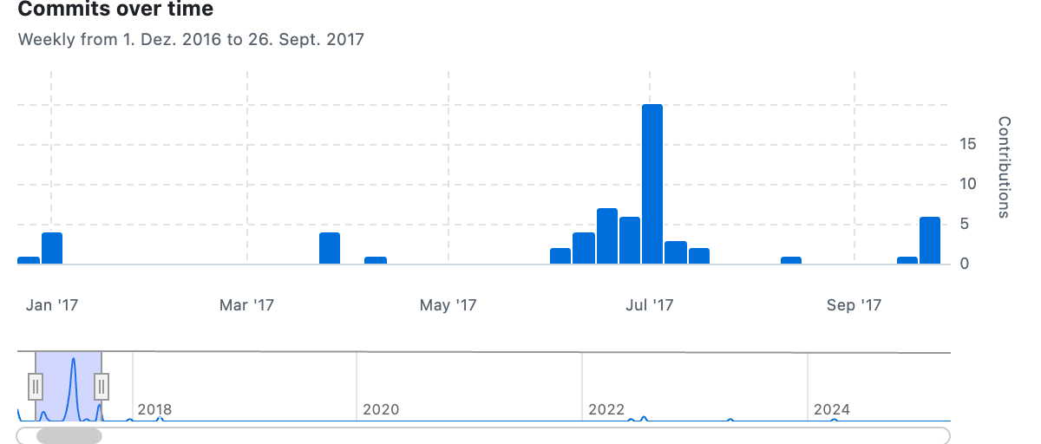

## Messages

**Wed, 28 Dec 2016 12:57:41**  
First commit

In this initial state we basically have a jQuery UI setup with a theme I made in the Theme Roller, and some test code trying to figure out how to make checkboxes and radio buttons look the way I want (e.g. similar to It is as if you were playing chess)

**Thu, 05 Jan 2017 11:50:25**  
CSS and implementing more widgets

Finally got the dot in the radio to be white Added various other widgets with variable success Discovered the ΓÇ£controlgroupΓÇ¥ which may help with setup (kind of like abandoning format over to jquery UI?)

**Thu, 05 Jan 2017 12:08:35**  
Menu generation (first attempt, buggy)

**Thu, 05 Jan 2017 12:57:36**  
Created process document from Evernote document

**Thu, 05 Jan 2017 12:57:58**  
Screenshot of early test case

**Mon, 27 Mar 2017 16:04:38**  
Got a prototype with radio buttons running

**Wed, 29 Mar 2017 16:49:10**  
Added a bunch of stuff, so much I forget. Worrying about mobile.

**Wed, 29 Mar 2017 20:28:54**  
Well at least some shit works right?

**Fri, 31 Mar 2017 14:17:58**  
Added process image

**Tue, 11 Apr 2017 07:54:36**  
Added lodash for no apparent reason?

**Fri, 09 Jun 2017 11:00:57**  
Added a bunch of CSS and code for different dialog elements

**Sat, 10 Jun 2017 00:12:10**  
Separated UI stuff, made semi progress, wrote about structure

**Thu, 15 Jun 2017 10:55:16**  
So many changes. I have been a bad person.

**Thu, 15 Jun 2017 12:15:04**  
Added new desktop images, added music selection, improved menu bar

**Fri, 16 Jun 2017 15:49:09**  
Added icons for music, desktop, game

**Fri, 16 Jun 2017 18:14:48**  
Modal darker, added basic starting workflow and states, hilarious ‘not ready’ sequence

**Sun, 18 Jun 2017 19:03:24**  
Updated process

**Mon, 19 Jun 2017 15:53:16**  
Added inspirational quotes, document editing

**Tue, 20 Jun 2017 12:26:17**  
Email subject/address, replaced Lorem Ipsum with technologies from Kazemi

**Tue, 20 Jun 2017 17:39:15**  
Working breakout game!

**Tue, 20 Jun 2017 17:40:40**  
Removed some old jquery crap

**Wed, 21 Jun 2017 21:56:31**  
Breakout + Breaks

* Made Breakout look more like it belongs (background colour)
* Tried to get Breakout to integrate and start/stop (failed)
* Added a proper break timer that clears all dialogs and shows a progress bar
* Created a job titler that can give random ranks
* Gave all dialogs classes to make it easier to get hold of them

**Sat, 24 Jun 2017 15:16:55**  
Post MacBook Pro commit

* A bunch of .DS_Store files
* Some tiny refactoring of todos

**Wed, 28 Jun 2017 20:43:03**  
Testable candidate?

* Added handling of window resize (non-responsive!)
* Added more sounds
* Added work units and promotions
* Fixed various button behaviours and consistency
* Like a boss

**Wed, 28 Jun 2017 21:52:16**  
Trying to only run when audio loaded

**Wed, 28 Jun 2017 21:53:17**  
Increased units for promotion

**Thu, 29 Jun 2017 11:56:17**  
Added process thoughts as of this version.

**Sat, 01 Jul 2017 12:21:06**  
Process update

* Added correspondence file with playtesting emails from J+M
* Added thoughts about playtest + new todos based on the results

**Sat, 01 Jul 2017 19:31:11**  
About dialog, inspirational texts

* Added an about dialog (but not the text)
* Fixed it so that after a break it restores the previous dialogs
* Edited the inspirational phrases to remove over-specific ones and to be gender neutral
* Added new desktop images that are CC0 and better

**Sun, 02 Jul 2017 09:15:26**  
Textual updates

* Changed the technologies to have title case for more impressiveness
* Changed typing activity to include headings that are technologies interspersed with the inspirational text
* Fixed a bug with undefined button labels

**Sun, 02 Jul 2017 14:49:38**  
Updated promotion system

* More serious title for positions
* Slower promotions, more work units per promotion
* Adjusted timing

**Sun, 02 Jul 2017 15:31:16**  
About text + tweaks

* Wrote an about text for dialog
* Adjusted spinner and datepicker to be a bit more reasonable
* Process image of about dialog

**Sun, 02 Jul 2017 21:58:48**  
Press

* Created press kit text
* Made trailer
* Took screenshots
* Added base-level readme
* Tweaked required characters for typing activities

**Sun, 02 Jul 2017 22:00:11**  
Added sound effect to login and ready to work dialogs

**Mon, 03 Jul 2017 10:22:01**  
Process + tweaks

* Updated correspondence
* Changed title in index.html
* Edited About text
* Added screenshot of how I created the titling for the trailer in textedit ha ha

**Mon, 03 Jul 2017 10:27:13**  
Small tweaks to press kit

**Mon, 03 Jul 2017 10:30:52**  
Added credit for Darius Kazemi’s corpora!

**Mon, 03 Jul 2017 10:53:38**  
Sent press emails, oh god

**Tue, 04 Jul 2017 09:50:17**  
Bug fix, press

* Added RPS press clipping
* Fixed bug where you can select and delete text in textarea and break input

**Tue, 04 Jul 2017 12:04:00**  
Added homepage URL as administrator to login and about

**Tue, 04 Jul 2017 14:46:49**  
Added press and tweets

**Tue, 04 Jul 2017 18:40:07**  
More press, tweak

* Added press
* Tweaked to allow copy and select from textarea so @sonblaireau can capture the text for their patreon

**Tue, 04 Jul 2017 18:44:31**  
Reverted last changes since it isn’t what they wanted.

**Wed, 05 Jul 2017 11:24:37**  
Promotion Blocker

Could not reach CTO level, as givePromotion would crash.

**Wed, 05 Jul 2017 09:36:04**  
Bug fix, press kit

* Disable close on escape for all dialogs
* Added ‘about me’ to press kit

**Wed, 05 Jul 2017 10:14:10**  
Updated press ‘about’

**Wed, 05 Jul 2017 21:18:49**  
Added press and tweets

**Thu, 06 Jul 2017 13:53:47**  
Added press, social media

**Thu, 06 Jul 2017 14:04:15**  
More press captures

**Sun, 09 Jul 2017 13:07:57**  
Press updates

**Wed, 12 Jul 2017 09:27:47**  
Added press

**Fri, 14 Jul 2017 13:45:22**  
More press

**Wed, 19 Jul 2017 10:12:02**  
More press, bugfix

* Added more press including article from Hyperallergic
* Correct issue with using lodash random on array index where I wasn’t using -1 on length to correct for its behaviour

**Wed, 19 Jul 2017 10:15:31**  
Doing another commit to try to get a press article to upload…

**Sun, 13 Aug 2017 19:54:19**  
Guess I added some press

**Fri, 22 Sep 2017 10:50:44**  
Added new press

**Sun, 24 Sep 2017 22:00:45**  
Removed articles directory for space reasons

**Sun, 24 Sep 2017 23:05:14**  
Add full copy of license

**Sun, 24 Sep 2017 23:18:38**  
Remove .DS_Store files

**Sun, 24 Sep 2017 23:22:00**  
Remove more .DS_Store files

**Wed, 27 Sep 2017 11:40:55**  
Added press

**Wed, 27 Sep 2017 11:46:04**  
Trying to refer to commit 6559bb2

**Tue, 02 Jan 2018 21:24:48**  
Press: added entry

**Mon, 02 Apr 2018 18:08:59**  
Updated Polansky link

**Thu, 05 Apr 2018 12:30:02**  
Added new Polansky article

**Mon, 13 Jun 2022 11:16:46**  
Added info dir

**Wed, 20 Jul 2022 16:56:57**  
Updated to new website standard

**Wed, 20 Jul 2022 17:12:52**  
Added press and process landing

**Wed, 03 May 2023 13:40:11**  
Fixed broken link to correspondence

**Tue, 02 Apr 2024 15:50:36**  
Added The White Pube review

# File Structure

## 2016-12-28

🖥️ It is as if you were doing work/  
├── 📁 css/  
 ├── 📁 external/  
 ├── 📁 images/  
 ├── AUTHORS.txt  
 ├── index.html  
 ├── jquery-ui.css  
 ├── jquery-ui.js  
 ├── jquery-ui.min.css  
 ├── jquery-ui.min.js  
 ├── jquery-ui.structure.css  
 ├── jquery-ui.structure.min.css  
 ├── jquery-ui.theme.css  
 ├── jquery-ui.theme.min.css`  
 ├── LICENSE.txt  
 └── package.json   
├── 📁 js/  
 └── uigame.js  
└── index.html

## 2017-01-05

🖥️ It is as if you were doing work/  
├── 📁 css/  
 ├── 📁 external/  
 ├── 📁 images/  
 ├── AUTHORS.txt  
 ├── index.html  
 ├── jquery-ui.css  
 ├── jquery-ui.js  
 ├── jquery-ui.min.css  
 ├── jquery-ui.min.js  
 ├── jquery-ui.structure.css  
 ├── jquery-ui.structure.min.css  
 ├── jquery-ui.theme.css  
 ├── jquery-ui.theme.min.css`  
 ├── LICENSE.txt  
 ├── package.json  
 └── style.css  
├── 📁 js/  
├── 📁 process/  
└── index.html

## 2017-03-29

🖥️ It is as if you were doing work/  
├── 📁 css/  
├── 📁 js/  
 ├── game.js  
 └── lodash.min.js  
├── 📁 process/  
└── index.html

## 2017-06-09

🖥️ It is as if you were doing work/  
├── 📁 css/  
 ├── 📁 external/  
 ├── 📁 images/  
 ├── 📁 old/  
 ├── AUTHORS.txt  
 ├── index.html  
 ├── jquery-ui.css  
 ├── jquery-ui.js  
 ├── jquery-ui.min.css  
 ├── jquery-ui.min.js  
 ├── jquery-ui.structure.css  
 ├── jquery-ui.structure.min.css  
 ├── jquery-ui.theme.css  
 ├── jquery-ui.theme.min.css`  
 ├── LICENSE.txt  
 ├── package.json  
 └── style.css  
├── 📁 images/  
├── 📁 js/  
├── 📁 process/  
└── index.html

## 2017-06-10

🖥️ It is as if you were doing work/  
├── 📁 css/  
├── 📁 images/  
├── 📁 js/  
 ├── game.js  
 ├── lodash.min.js  
 └── ui-generators.js  
├── 📁 process/  
└── index.html

## 2017-06-15

🖥️ It is as if you were doing work/  
├── 📁 assets/  
 ├── 📁 images/  
 └── 📁 sounds/  
├── 📁 css/  
├── 📁 js/  
├── 📁 process/  
└── index.html

## 2017-06-19

🖥️ It is as if you were doing work/  
├── 📁 assets/  
├── 📁 css/  
├── 📁 js/  
 ├── data.js  
 ├── game.js  
 ├── lodash.min.js  
 └── ui-generators.js  
├── 📁 process/  
└── index.html

## 2017-06-20

🖥️ It is as if you were doing work/  
├── 📁 assets/  
├── 📁 css/  
├── 📁 js/  
 ├── 📁 breakout/  
 ├── 📁 images/  
 ├── 📁 music/  
 ├── 📁 sounds/  
 ├── Boot.js  
 ├── Breakout.js  
 ├── phaser.min.js  
 └── Preloader.js  
 ├── data.js  
 ├── game.js  
 ├── lodash.min.js  
 └── ui-generators.js  
├── 📁 process/  
└── index.html

## 2017-06-24

🖥️ It is as if you were doing work/  
├── 📁 assets/  
├── 📁 css/  
├── 📁 js/  
├── 📁 process/  
 ├── 📁 images/  
 ├── .DS_Store  
 └── README.md  
├── .DS_Store  
└── index.html

## 2024-04-02

🖥️ It is as if you were doing work/  
├── 📁 assets/  
 ├── 📁 css/  
 ├── style.css  
 ├── 📁 images/  
 ├── 📁 sounds/  
 └── .DS_Store  
├── 📁 css/  
├── 📁 info/  
 ├── 📁 images/  
 └── README.md  
├── 📁 js/  
├── 📁 press/  
├── 📁 process/  
 ├── 📁 images/  
 ├── .DS_Store  
 ├── blog-posts.md  
 ├── CORRESPONDENCE.md  
 ├── journal.md  
 ├── README.md  
 └── to-do.md  
├── .DS_Store  
├── .gitignore  
├── _config.yml  
├── index.html  
├── LICENSE  
└── README.md

# Press

* O’Connor, Alice. [*It is as if you were doing work really is*](https://www.rockpapershotgun.com/2017/07/04/free-desktop-work-simulator/). 4 July 2017. Rock, Paper, Shotgun.
* Beschizza, Rob. [*It Is As If You Were Doing Work is a browser game celebrating Windows 3-era cubicle drudgery*](http://boingboing.net/2017/07/04/it-is-as-if-you-were-doing-wor.html). 4 July 2017. Boing Boing.
* [*Канадец создал симулятор офисного работника. Сыграйте в него на работе*](https://meduza.io/shapito/2017/07/04/kanadets-sozdal-simulyator-ofisnogo-rabotnika-sygrayte-v-nego-na-rabote). 4 July 2017. Meduza.
* Porreca, Ray. [*This browser game simulates workplace tedium and soul-crushing, endless memos*](https://www.destructoid.com/this-browser-game-simulates-workplace-tedium-and-soul-crushing-endless-memos-446844.phtml). 4 July 2017. Destructoid.
* Hulfish, Garrett. [PREFER WORK TO LIFE? TRY THE ‘IT IS AS IF YOU WERE DOING WORK’ GAME](https://www.digitaltrends.com/gaming/doing-work-browser-game/). Digital Trends. 5 July 2017.
* Vincent, Brittany. [‘It Is As If You Were Doing Work’ browser game perfectly encapsulates the life of an office worker](https://mic.com/articles/181513/it-is-as-if-you-were-doing-work-browser-game-perfectly-encapsulates-the-life-of-an-office-worker#.IhuGvyNsT). Mic. 5 July 2017.
* Cole, Samantha. [This Game Simulates the Thrill of Working On a Computer](https://motherboard.vice.com/en_us/article/3knd8b/this-game-simulates-the-thrill-of-working-on-a-computer). Motherboard. 5 July 2017.
* Bergert, Denise. [Langweiliger Bürojob als Browserspiel - “It is as if you were doing work”](https://www.pcwelt.de/a/langweiliger-buerojob-als-browserspiel-it-is-as-if-you-were-doing-work,3447298). 5 July 2017. PC Welt.
* Linken, Andre. [It is as if you were doing work - Browserspiel simuliert langweiligen Bürojob](http://www.gamestar.de/artikel/it-is-as-if-you-were-doing-work-browserspiel-simuliert-langweiligen-buerojob,3316648.html). 5 July 2017. GameStar.
* Bonke, Michael. [It is as if you were doing work: Die langweiligste Simulation aller Zeiten?](http://www.pcgames.de/Panorama-Thema-233992/News/It-is-as-if-you-were-doing-work-Die-langweiligste-Simulation-aller-Zeiten-1232379/). 5 July 2017. PC Games (DE).
* Priestman, Chris. [It is as if you were doing work](http://warpdoor.com/2017/07/05/it-is-as-if-you-were-doing-work-pippin-barr/). Warp Door. 5 July 2017.
* Ziegener, Daniel. [It is as if you were doing work v1.0](https://superlevel.de/spiele/it-is-as-if-you-were-doing-work-v1-0/). 5 July 2017. Superlevel.
* Vincent, James. [Relive the Windows 95 glory days with this work simulation game](https://www.theverge.com/tldr/2017/7/6/15927338/work-simulation-game-windows-95-pippin-barr). 6 July 2017. The Verge.
* Förtsch, Michael. [Dieses Bürojob-Webgame treibt einen in den Wahnsinn](https://www.wired.de/collection/life/webgame-pippin-barr-arbeit-simulation). 6 July 2017. Wired (Germany).
* Biggs, John. [New game simulates the old grind](https://techcrunch.com/2017/07/06/new-game-simulates-the-old-grind/). 6 July 2017. Tech Crunch.
* Regan, Tom. [Recreate the thrills of ’90s PC admin in this browser game](https://www.engadget.com/2017/07/06/recreate-the-thrills-of-90s-pc-admin-in-this-browser-game/). 6 July 2017. Engadget.
* Homola, Adam. [It is as if you were doing work simuluje práci ve světě, kde všechno dělají roboti](https://games.tiscali.cz/preview/it-is-as-if-you-were-doing-work-simuluje-praci-ve-svete-kde-vsechno-delaji-roboti-299838). 6 July 2017. Games.cz.
* [Ce jeu vous demande de faire tout ce que vous faites déjà au boulot](http://www.ufunk.net/jeux-videos/it-is-as-if-you-were-doing-work/). 6 July 2017. UFunk.
* Arraché, Eric. [Jogo viciante de hoje simula a tortura que era usar o Windows 95 para trabalhar](http://criticalhits.com.br/jogo-viciante-de-hoje-simula-tortura-que-era-usar-o-windows-95-para-trabalhar/). 6 July 2017. Critical Hits.
* Pierre. [Ce jeu en ligne vous fait revivre l’enfer d’un employé de bureau des années 90](http://www.journaldugeek.com/2017/07/06/ce-jeu-en-ligne-vous-fait-revivre-lenfer-dun-employe-de-bureau-des-annees-90/)./ 6 July 2017. Journal du Geek.
* Cantisano, Timi. [Transport yourself back to the era of Windows 95 with this cleverly-built office simulator](https://www.neowin.net/news/transport-yourself-back-to-the-era-of-windows-95-with-this-cleverly-built-office-simulator). 7 July 2017. Neowin.
* Lellouche, Nicolas. [Redécouvrez Windows 95 dans un navigateur Internet](http://www.lefigaro.fr/secteur/high-tech/2017/07/07/32001-20170707ARTFIG00005-redecouvrez-windows-95-dans-un-navigateur-internet.php). 7 July 2017. Le Figaro.
* Mathieu, Bruno. [Cet émulateur de Windows 95 vous fait travailler en jouant (ou l’inverse)](https://www.tomsguide.fr/actualite/windows-95-emulateur-travail,58038.html). 7 July 2017. Tom’s Guide.
* [Nostalgie: Revivez l’expérience Windows 95 grâce à un hilarant simulateur gratuit](http://www.20minutes.fr/insolite/2101219-20170707-nostalgie-revivez-experience-windows-95-grace-hilarant-simulateur-gratuit). 7 July 2017. 20 Minutes.
* Tomaszkiewicz, Michał [Symulator pracy wciąga na całe dni robocze](http://www.antyradio.pl/Technologia/Duperele/Symulator-pracy-wciaga-na-cale-dni-robocze-16100). 7 July 2017. Antyradio.pl.
* Pavlenko, Dimitri. [Nostalgie : un mini-jeu émule Windows 95 dans votre navigateur web](http://www.clubic.com/humour-informatique-geek/actualite-833246-nostalgie-mini-jeu-emule-windows-95-navigateur-web.html). 9 July 2017. Clubic.
* Taglinger, Harald. [Wilde Zeiten in der Windows-95-Welt](https://www.heise.de/tp/news/Wilde-Zeiten-in-der-Windows-95-Welt-3766792.html). 10 July 2017. Telepolis.
* Gévaudan, Camille. [«It is as if you were doing work», emploi fictif](http://www.liberation.fr/futurs/2017/07/11/it-is-as-if-you-were-doing-work-emploi-fictif_1583145). 11 July 2017. Libération.
* Douglas, Nick. [Officecore: 10 Games That Simulate Boring Jobs](http://lifehacker.com/officecore-10-games-that-simulate-boring-jobs-1796685998). 14 July 2017. Lifehacker.
* Ganapathi, Anusha. [What is the point, really?](http://www.newindianexpress.com/cities/chennai/2017/jul/15/what-is-the-point-really-1628811.html). 15 July 2017. The New Indian Express.
* Meier, Allison. [A Browser Game Recreates the Tedium of a 1990s Office Job](https://hyperallergic.com/390914/pippin-barr-it-is-as-if-you-were-doing-work-game/). Hyperallergic. 18 July 2017.
* Kaczmarczyk, Karolina. [pippin barr: it is as if you were doing work](http://www.next-level.org/details/pippin_barr_it_is_as_if_you_were_doing_work/#/). Next Level. 18 July 2017.
* Machiavelli, Gui. [IT IS AS IF YOU WERE DOING WORK (REVIEW)](http://ilu.servus.at/issue11.html). Persuasive Labor Union Special Issue #2 “The Entreprecariat”. 10 September 2017.
* Cleon. [It Is As If You Were Doing Work But Actually You’re Playing A Video Game](http://tay.kinja.com/it-is-as-if-you-were-doing-work-but-actually-youre-play-1818728688?rev=1506357501356). 25 September 2017.
* Polansky, Lana. [Gaming on the Fringe: 2017 Roundup](http://sufficientlyhuman.com/archives/1557). Sufficiently Human. 2 January 2018.
* Macharia, Tyra. [Artcade Brought a Whole New Meaning to Game Developing](https://thelinknewspaper.ca/article/artcade-2018-concordia). The Link. 10 March 2018.
* Polansky, Lana. [Notes on It’s As If You Were Doing Work: Do Nothing, Feel Fine](http://sufficientlyhuman.com/archives/1590). Sufficiently Human. 3 April 2018.
* de la Puente, Gabrielle. [It is as if you were doing work](https://thewhitepube.co.uk/reviews/2024/it-is-as-if-you-were-doing-work/). The White Pube. 24 March 2024.

### Radio

* [Program: forwards and backwards](http://www.deutschlandfunkkultur.de/suchergebnisse.2544.de.html?search%5Bword%5D=pippin&search%5Bsubmit%5D=1). 20 July 2017. Deutchlandfunk Kultur.

# Imprint

The evolution of…  
It is as if you were doing work (2017)

See: Love.

1. Barr, P., Khaled, R. and Lessard, J. (2018) ‘Documenting trajectories in design space: a methodology for applied game design research’, in Proceedings of the 13th International Conference on the Foundations of Digital Games. Foundations of Digital Games 2018, Malmö Sweden.
2. Barr, P. (2023) The Stuff Games Are Made Of. Cambridge, Massachusetts; London, England: The MIT Press (Playful Thinking).
3. [pippinbarr.com/itisasifyouweredoingwork](http://www.pippinbarr.com/itisasifyouweredoingwork/)
4. [speculativeplay.com](https://www.speculativeplay.com)
5. [github.com/dariusk/corpora/tree/master/data/technology](https://github.com/dariusk/corpora/tree/master/data/technology)
6. [youtube.com/watch?v=RDMiRiHcezI](https://www.youtube.com/watch?v=RDMiRiHcezI)